GRU-BASED PREDICTIVE ROUTE OPTIMISATION FRAMEWORK FOR EMERGENCY VEHICLE NAVIGATION

BY

FRESHIA NJOKI MACHARIA
PA206/S/25427/24

A THESIS SUBMITTED IN PARTIAL FULFILLMENT OF THE REQUIREMENTS
FOR THE DEGREE OF MASTER OF SCIENCE IN COMPUTER SCIENCE
OF KIRINYAGA UNIVERSITY

August 2026
DECLARATION
I/We confirm that the work reported in this thesis was carried out by the candidate under my/our supervision.
Signed: ________________________________ Date: ________________________
Name: Dr. Gilbert Langat, PhD
Lecturer, School of Pure and Applied Sciences
Kirinyaga University
Signed: ________________________________Date: ____________________
Name: Dr. Stephen Mageto, PhD
Lecturer, School of Pure and Applied Sciences
Kirinyaga University

Copyright
© 2026 Freshia Njoki Macharia
All rights reserved. No part of this thesis may be reproduced, stored in any retrieval system or transmitted in any form or by any means, electronically, mechanically, by photocopying or otherwise, without prior written permission of the author or Kirinyaga University on that behalf.

DEDICATION
To the emergency responders of Nairobi and every city where minutes determine lives.

ACKNOWLEDGEMENT
I am deeply grateful to my supervisors, Dr. Gilbert Langat and Dr. Mageto Stephen, for their expert guidance, critical feedback, and continued support throughout this research. Their insights shaped both the technical rigour and academic quality of this work.
I acknowledge Kirinyaga University for providing enabling support for postgraduate research in computer science. I thank the developers of the METR-LA and PEMS-BAY datasets and the open-source communities behind TensorFlow, NetworkX, and OSMnx, without whose contributions this research would not have been computationally feasible.

ABSTRACT
This study designed, implemented, and evaluated an Intelligent Route Optimisation Framework for emergency vehicle navigation by integrating short-term traffic prediction with time-dependent adaptive pathfinding, guided by four specific objectives: to review existing literature identifying research gaps that informed the framework design; to develop an integrated Route Recommendation System combining a Gated Recurrent Unit (GRU)-based traffic prediction module with a Time-Dependent A* (TD-A*) routing algorithm and a threshold-based replanning controller; to determine the optimal replanning threshold policy (δ) across δ ∈ {5%, 10%, 15%, 20%} balancing route reliability against computational overhead; and to evaluate framework performance through simulation-based experiments against Dijkstra, Static A*, and Oracle A* baselines. The GRU model was trained on the METR-LA and PEMS-BAY dataset comprising 207 sensors and 34,254 five-minute observations and forecast traffic speeds 15 to 30 minutes ahead; these predictions were converted into time-dependent edge cost functions consumed by the TD-A* routing algorithm. An adaptive controller monitored simulated vehicle progress and issued updated route recommendations when observed conditions deviated from predictions beyond the configured threshold. Simulation experiments were conducted across 900 origin-destination experiments (75 pairs × 3 traffic scenarios × 4 threshold values) on a real 397-node OpenStreetMap road network derived from Los Angeles County. The framework produced a statistically significant travel time reduction in incident conditions (+0.17%, p = 0.004). TD-A* routing latency averaged 0.315 milliseconds — approximately 3,175 times below the 1,000-millisecond sub-second dispatch target — confirming computational feasibility for real-time emergency dispatch. One-way ANOVA confirmed that route quality was consistent across all four threshold values (F = 0.000, P = 1.000), supporting δ = 0.10 as the recommended operational default. The framework was designed as a dispatcher decision support tool retaining human authority over final route selection, with primary beneficiaries including emergency dispatch centres, ambulance services, fire departments, and police units in congested urban environments — particularly rapidly growing cities such as Nairobi, Kenya, where peak-hour ambulance response times average 18 to 25 minutes against the World Health Organisation's recommended eight-minute threshold.

TABLE OF CONTENTS

CHAPTER ONE: INTRODUCTION 1
1.1 Background of the Study 1
Global Perspective 1
1.2 Statement of the Problem 5
1.3 Purpose of the Study 6
1.4 Research Objectives 6
1.5 Research Questions 7
1.6 Justification of the Study 8
1.7 Limitations 8
1.8 Delimitations 9
1.9 Assumptions 9
1.10 Operational Definition of Terms 10
CHAPTER TWO: LITERATURE REVIEW 12
2.1 Introduction 12
2.2 Classical Pathfinding Algorithms 12
2.3 Time-Dependent Shortest Path Problem 14
2.4 Traffic Prediction Using Machine Learning 15
2.5 Integration of Prediction and Routing 17
2.6 Emergency Vehicle Routing 17
2.7 Research Gaps 19
2.8 Theoretical Framework 20
2.8.1 Theory 1 — Time-Dependent Shortest Path (TDSP) Theory 20
2.8.2 Theory 2 — GRU Architecture for Sequence Modelling 21
2.8.3 Theory 3 — Decision Support Systems (DSS) Theory 22
2.9 Conceptual Framework 23
CHAPTER THREE: RESEARCH METHODOLOGY 29
3.1 Introduction 29
3.2 Research Philosophy 29
3.3 Research Design 30
3.4 Data Collection 31
3.5 Data Instruments 33
3.6 GRU Traffic Prediction Module Development 35
3.7 Time-Dependent Routing Algorithm 36
3.8 Route Recommendation Mechanism 37
3.9 Evaluation Metrics and Experimental Setup 37
3.10 Data Analysis Methods 39
3.11 Validity and Reliability 39
3.12 Ethical Considerations 40
CHAPTER FOUR: RESULTS AND FINDINGS 41
4.1 Introduction 41
4.2 Objective 1: Literature Review Findings 41
4.3 Objective 2: Framework Development Findings 44
4.3.1 GRU Traffic Prediction Module 44
4.3.2 Road Network and Sensor Mapping 50
4.3.3 Framework Integration and Implementation 53
4.3.4 Cross-Dataset Validation — PEMS-BAY 55
4.4 Objective 3: Threshold Policy Analysis Findings 59
4.5 Objective 4: Framework Evaluation Findings 63
4.5.1 Travel Time Reduction 63
4.5.2 Computational Performance 68
4.6 Discussion 71
4.6.1 Travel Time Reduction 71
4.6.2 Computational Feasibility 72
4.6.3 Threshold Policy 73
4.6.4 Limitations of Results 74
4.7 Chapter Summary 74
CHAPTER FIVE: SUMMARY, CONCLUSIONS AND RECOMMENDATIONS 76
5.1 Introduction 76
5.2 Summary 76
5.3 Conclusions 78
5.4 Recommendations 80
5.4.1 Recommendations Based on Research Findings 80
5.4.2 Recommendations for Policy 81
5.5 Suggestions for Further Research 81
REFERENCES 83
APPENDIX A: SOURCE CODE REPOSITORY 86

LIST OF TABLES
Table | Title | Page
3.1 | Alignment of Objectives, Research Questions, Data Sources, and Analysis Methods | 34
4.1 | Gap Analysis — Literature Review Coverage and Identified Research Gaps | 42
4.2 | GRU Model Architecture and Training Configuration | 45
4.3 | GRU Model Training and Validation Performance Metrics | 47
4.4 | Road Network Properties for the Study Area | 51
4.4b | Implementation Files and Their Functions | 54
4.4c | GRU Cross-Dataset Validation — METR-LA vs PEMS-BAY | 56
4.5 | Framework vs Baseline Mean Travel Times by Scenario | 64
4.6 | Statistical Significance of Travel Time Reductions vs Dijkstra Baseline | 66
4.7 | Threshold Policy Sensitivity Analysis | 60
4.8 | Computational Latency by Scenario | 69
5.1 | Mapping of Research Objectives to Conclusions | 79

LIST OF FIGURES
Figure | Title | Page
1.1 | Traffic Volatility Impact on Emergency Response Times — Nairobi CBD vs WHO Recommended Target | 4
2.1 | Conceptual Framework — Intelligent Route Optimisation Framework for Emergency Vehicle Navigation | 27
4.1 | GRU Model Training History — Training and Validation Loss Curves over Training Epochs | 46
4.2 | GRU Speed Prediction vs Actual Values — Sample from METR-LA Test Set | 49
4.3 | Study Area Road Network — 397 Nodes, 1,024 Edges (190 Sensor-Mapped Edges Highlighted) | 52
4.4 | Threshold Sensitivity Analysis — Travel Time Reduction and Update Frequency by Delta Value | 62
4.5 | Mean Travel Times — TD-A* + GRU Framework vs All Baselines by Traffic Scenario | 65
4.6 | Framework Travel Time Reduction vs Each Baseline — Three Traffic Scenarios with Error Bars | 67
4.7 | Computational Performance — TD-A* Routing Latency and GRU Inference Time by Traffic Scenario | 70
4.8 | GRU Training History Comparison — METR-LA (207 Sensors) vs PEMS-BAY (325 Sensors) | 58

LIST OF ABBREVIATIONS
ANOVA Analysis of Variance
API Application Programming Interface
ARIMA Autoregressive Integrated Moving Average
CPU Central Processing Unit
DCRNN Diffusion Convolutional Recurrent Neural Network
DSS Decision Support Systems
DSRM Design Science Research Methodology
FIFO First In, First Out
GNN Graph Neural Network
GRU Gated Recurrent Unit
ITS Intelligent Transportation Systems
LSTM Long Short-Term Memory
MAE Mean Absolute Error
METR-LA Metropolitan Traffic Dataset — Los Angeles
OD Origin-Destination
OSM OpenStreetMap
PEMS-BAY Performance Measurement System — Bay Area
RMSE Root Mean Square Error
RNN Recurrent Neural Network
TD-A* Time-Dependent A* Algorithm
TDSP Time-Dependent Shortest Path
WHO World Health Organisation

CHAPTER ONE: INTRODUCTION

Background of the Study
Global Perspective
Intelligent transportation systems (ITS) emerged as a critical domain at the intersection of computer science, urban planning, and public safety, offering data-driven solutions to the management of complex urban mobility. Within ITS, emergency vehicle navigation represented one of the highest-stakes applications: the ability to route an ambulance, fire engine, or police unit to its destination with minimal delay was a direct determinant of life safety outcomes. Despite significant advances in routing algorithms and machine learning-based traffic prediction, the integration of these two capabilities into a unified, computationally efficient decision-support framework for emergency dispatch remained an open research challenge (Binshaflout & Ahmad, 2023; Judijanto & Rismanto, 2021).
Urban traffic congestion posed a direct threat to public safety globally. The International Transport Forum (2023) estimated that congestion costs OECD economies over USD 1 trillion annually, while research indicated that ambulance response times increased by 30 to 50 percent during peak-hour congestion in major metropolitan areas. Traditional navigation systems, including commercial platforms such as Google Maps and Waze, primarily relied on historical or current traffic data without forecasting conditions over the course of an emergency journey (Binshaflout & Ahmad, 2023). A route optimised at the point of dispatch became suboptimal within 10 to 15 minutes as congestion patterns shifted. The consequences were severe: delayed arrivals at cardiac arrest scenes increased mortality by approximately 10 percent per additional minute (Zhang, Sun, & Liu, 2022), while delayed fire and police responses amplified property loss and public safety risk. These consequences of static route recommendations constituted the fundamental problem motivating this research.
Regional Perspective
In Sub-Saharan Africa, rapid urbanisation intensified these challenges considerably. The United Nations Economic Commission for Africa (UNECA, 2022) reported that African urban populations were projected to triple by 2050, with major cities including Lagos, Nairobi, Accra, and Dar es Salaam among the most congested in the world, significantly undermining emergency service performance (Golub, Stevens, Klopp, & Martin, 2021). The African Development Bank found that inadequate transportation infrastructure contributed to emergency response delays of up to 60 percent beyond recommended thresholds across several East African capitals (AfDB, 2022). Most Sub-Saharan African cities lacked integrated emergency dispatch systems with real-time traffic awareness, and mixed-traffic conditions, including matatus, motorcycles, and pedestrians — created dynamics fundamentally different from those modelled by systems designed for Western urban contexts (Mugeere, Munene, & Nsubuga, 2020).
Local Perspective
The Nairobi context was particularly acute. Annual congestion costs were estimated at Ksh 163.2 billion, with average ambulance response times in the Central Business District ranging from 18 to 25 minutes during peak hours — far exceeding the World Health Organisation's recommended eight-minute target for life-threatening emergencies (WHO, 2015; INRIX, 2024; Streamline Feed, 2025). Kenya lacked a nationally integrated emergency dispatch system with real-time predictive routing capability. The Nairobi Metropolitan Services operated without sensor-integrated route optimisation tools, and available commercial navigation systems did not account for the matatu-dominated, mixed-traffic dynamics characteristic of Kenyan urban corridors (Mugeere et al., 2020). Recent infrastructure assessments confirmed that Kenyan emergency response systems remained below minimum performance thresholds (AfDB, 2022), making the development of computationally feasible predictive routing an urgent local priority. Recent evidence confirms that technology-driven routing improvements can be transformative in Kenyan contexts: Reis et al. (2025) documented a reduction in urban emergency response times from over 160 minutes to 13 minutes following deployment of real-time dispatch routing, while Ikram et al. (2025) demonstrated that dynamic routing algorithms outperformed static shortest-path approaches for emergency vehicle navigation in congested urban networks.

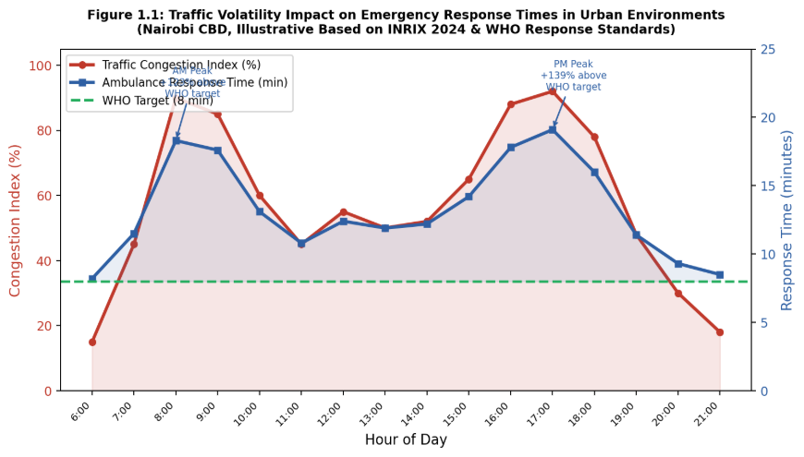
Figure 1.1: Traffic Volatility Impact on Emergency Response Times in Urban Environments (Nairobi CBD, Illustrative — INRIX, 2024 & WHO, 2015)

Research in ITS produced significant advances in two parallel domains: traffic prediction using machine learning models particularly GRU and LSTM networks and efficient pathfinding algorithms such as A* and Dijkstra variants (Judijanto & Rismanto, 2021). However, a critical gap existed in integrating these technologies into decision support systems capable of simultaneously predicting future traffic conditions and computing optimal routes that accounted for those predictions under real-time computational constraints. A 2025 systematic review by Qi et al. (2025) explicitly identified the disconnection between traffic prediction and path planning as the primary open problem in intelligent transportation research, confirming the timeliness of this study.

1.2 Statement of the Problem
Emergency vehicle dispatch in urban environments faced a critical challenge: existing navigation systems relied on static or real-time-only traffic data and failed to anticipate traffic volatility, producing route recommendations that became suboptimal within minutes of dispatch. This failure directly cost lives, as delayed ambulance arrivals increased cardiac arrest mortality by approximately 10 percent for every minute of delay, while delayed fire and police responses amplified property loss and public safety risk (Zhang, Sun, & Liu, 2022). Static route recommendations imposed two compounding dangers: first, vehicles arrived at road segments experiencing congestion that had developed after departure, adding avoidable delay; second, dispatchers operating without predictive information had no mechanism to anticipate developing bottlenecks and could not intervene until vehicles were already delayed, at which point every additional minute carried direct mortality consequences.
While machine learning models accurately predicted short-term traffic patterns and time-dependent pathfinding algorithms existed as separate research streams, no integrated decision-support framework simultaneously achieved prediction accuracy, computational efficiency, and adaptive route recommendation at a scale suitable for emergency dispatch centres (Abuaisha et al., 2025; Qi et al., 2025). This gap was particularly acute in rapidly congested cities such as Nairobi, where average ambulance response times exceeded the WHO-recommended eight-minute threshold by more than double during peak hours and dispatch infrastructure operated with limited computational resources (WHO, 2015; INRIX, 2024; Streamline Feed, 2025).

1.3 Purpose of the Study
The purpose of this study was to design and evaluate through simulation a scalable Intelligent Route Optimisation Framework demonstrating potential for significantly reducing emergency vehicle travel time by anticipating traffic volatility through integrated predictive modelling and adaptive pathfinding.

1.4 Research Objectives
General Objective
The general objective of this study was to design, develop, and evaluate an Intelligent Route Optimisation Framework for emergency vehicle navigation by integrating predictive traffic modelling with adaptive graph search techniques.

Specific Objectives
Specific Objective 1: To review existing literature on emergency vehicle routing systems, intelligent transportation frameworks, and traffic prediction techniques, producing a structured gap analysis that informed the design of the Intelligent Route Optimisation Framework.
Specific Objective 2: To develop an integrated Route Recommendation System combining a GRU-based traffic prediction module, a Time-Dependent A routing algorithm, and a threshold-based replanning controller, producing a validated dispatch decision support tool
Specific Objective 3: To determine the optimal replanning threshold policy (δ) balancing route reliability against computational overhead, evaluated empirically across δ ∈ {5%, 10%, 15%, 20%}.
Specific Objective 4: To evaluate framework performance through simulation-based experiments against Dijkstra and static A* baselines using travel time reduction, computational latency, and recommendation update frequency as primary metrics.
The gap analysis produced by Objective 1 directly informed the architecture of Objective 2 by confirming the absence of integrated prediction-routing systems as the primary unresolved challenge in the literature.

1.5 Research Questions
Research Question 1: What research gaps exist in the literature on emergency vehicle routing, traffic prediction, and time-dependent pathfinding that justify the development of an integrated predictive routing framework?
Research Question 2: How effectively did the integrated GRU-based traffic prediction module combined with the Time-Dependent A* algorithm generate emergency vehicle route recommendations compared to non-predictive systems?
Research Question 3: What was the optimal threshold policy (δ) for triggering route recommendation updates that balanced route reliability against computational overhead?
Research Question 4: To what extent did the proposed Intelligent Route Optimisation Framework demonstrate statistically significant performance improvements against established baselines across diverse traffic scenarios?

1.6 Justification of the Study
This research addressed a critical gap at the intersection of traffic prediction and route recommendation for emergency dispatch. Theoretically, it advanced intelligent transportation systems by integrating predictive modelling with adaptive graph search optimised for time-dependent routing under computational constraints — an area that had received insufficient attention in the literature (Judijanto & Rismanto, 2021; Qi et al., 2025). Practically, the research directly benefitted emergency services operating in congested urban environments, particularly ambulance services, fire brigades, and police units in cities like Nairobi, by offering a scalable decision support solution adaptable to resource-constrained dispatch environments. The economic impact was substantial, with the potential to mitigate billions in annual congestion-related losses while meaningfully improving public safety outcomes.

1.7 Limitations
The reliance on METR-LA (2012) and PEMS-BAY (2017) traffic datasets may not perfectly capture traffic patterns in Sub-Saharan African urban environments such as Nairobi. These datasets reflected freeway-dominant sensor configurations typical of developed-world infrastructure, differing from mixed-traffic urban conditions involving matatus, motorcycles, and informal pedestrian crossings. However, both datasets remained internationally established benchmarks used in over 100 peer-reviewed studies as recently as 2025 (Sahayaraj et al., 2024; Qi et al., 2025), providing the strongest available validated foundation for framework evaluation. Simulation-based evaluation could not fully replicate real-world operational complexity, and computational performance measurements were hardware-dependent. Sensor-to-edge mapping covered only 18.6% of graph edges; the remaining edges used free-flow speed estimates rather than GRU-predicted travel times.

1.8 Delimitations
This study focused on emergency vehicle routing in urban road networks with significant temporal traffic variability, using METR-LA as the primary evaluation dataset. The research was delimited to short-term prediction (15 to 30 minutes), simulation-based evaluation, and single-vehicle route optimisation. Road network modelling used OpenStreetMap data for Los Angeles County. The study excluded route preferences beyond travel time minimisation, multi-vehicle coordination, real-time sensor deployment, and operational field validation in actual dispatch centres.

1.9 Assumptions
This research assumed that historical traffic patterns in METR-LA and PEMS-BAY datasets represented sufficiently typical urban behaviour to train and validate predictive models. It was assumed that traffic sensors could be reliably mapped to OpenStreetMap road segments, that emergency vehicles experienced delays broadly correlating with general traffic conditions, and that FIFO properties held for road segments. Computational resources were assumed to fall within reasonable ranges for emergency vehicle dispatch systems.

1.10 Operational Definition of Terms
Adaptive Graph Search. Pathfinding that dynamically adjusted routes during traversal based on updated traffic information, rather than following a rigid pre-computed path.
Computational Latency. Time elapsed from route calculation request to solution delivery, measured in milliseconds. The target was sub-second (less than 1,000 ms) to support timely dispatch decisions.
Decision Support Tool. A system providing route recommendations and traffic forecasts to assist human dispatchers, while retaining human authority for final route selection.
Emergency Vehicle. Vehicles operated by emergency services (ambulances, fire engines, police) responding to urgent situations where travel time minimisation was critical to public safety.
Gated Recurrent Unit (GRU). A recurrent neural network architecture using gating mechanisms to capture temporal dependencies in sequential traffic data while maintaining computational efficiency (Cho et al., 2014).
Replanning Threshold (δ). A decision criterion triggering route recommendation updates when predicted traffic conditions deviated significantly from those assumed in the currently recommended route, expressed as a percentage deviation in estimated remaining travel time.
Time-Dependent Shortest Path (TDSP). A routing problem where travel time to traverse a road segment depended on departure time rather than being constant.

CHAPTER TWO: LITERATURE REVIEW

2.1 Introduction
This chapter presented a comprehensive review of existing literature on intelligent route optimisation, traffic prediction, and time-dependent pathfinding as they related to emergency vehicle navigation. The review was organised thematically to address: classical pathfinding algorithms; time-dependent shortest path problems; traffic prediction using machine learning; integration of prediction and routing; emergency vehicle routing applications; and identification of research gaps. The chapter concluded with the theoretical framework anchoring the study and the conceptual framework illustrating the interrelationships among key variables.

2.2 Classical Pathfinding Algorithms
The problem of computing shortest paths in weighted graphs had been studied extensively since the 1950s. Dijkstra's algorithm (1959) provided the canonical solution for non-negative weighted graphs, exploring nodes in order of cumulative cost with O((V+E) log V) complexity. While provably optimal for static graphs, Dijkstra's algorithm explored paths in all directions without exploiting destination information, making it computationally expensive for large urban road. The A* algorithm (Hart, Nilsson, & Raphael, 1968) improved practical efficiency by incorporating a heuristic function h(n) estimating remaining cost to the goal, yielding f(n) = g(n) + h(n). With admissible heuristics, A* guaranteed optimality while exploring far fewer nodes than Dijkstra. The haversine distance to the destination served as an admissible heuristic for urban routing.
Advanced approaches included Bidirectional Dijkstra (Pohl, 1971), Contraction Hierarchies (Geisberger et al., 2008), and the ALT algorithm (Goldberg & Harrelson, 2005). More recently, Gong et al. (2023) demonstrated shortcut-based approaches on time-dependent networks achieving significant speedups while preserving path optimality, and Chen et al. (2021) established the NP-completeness of online route planning over time-dependent networks. Dijkstra and static A* were selected as baselines in this study because they represented the current operational standard in emergency dispatch navigation systems: computationally reliable, well-understood, and available as reference implementations in Python's NetworkX library (Hagberg et al., 2024). Both shared a fundamental limitation: they assumed static edge weights, failing to account for temporal variation in urban travel times.
The computational complexity of classical shortest-path algorithms had significant implications for emergency dispatch applications. Dijkstra's algorithm, while guaranteeing optimality, ran in O((V + E) log V) time for a graph with V vertices and E edges — acceptable for small networks but potentially prohibitive as road networks scaled to thousands of nodes. Bidirectional Dijkstra halved average search space by expanding simultaneously from origin and destination, while Contraction Hierarchies pre-processed the graph by iteratively removing low-importance nodes and adding shortcut edges, achieving query times orders of magnitude faster than standard Dijkstra on continental road networks (Geisberger et al., 2008). ALT algorithms (A*, Landmarks, Triangle inequality) exploited pre-computed landmark distances as admissible heuristics, further accelerating queries (Goldberg & Harrelson, 2005). However, all classical acceleration techniques assumed static edge weights — once weights became time-dependent, the preprocessing guarantees broke down and required substantial modification. This tension between computational efficiency and time-dependency defined the primary algorithmic challenge motivating the adoption of TD-A* in this study.

2.3 Time-Dependent Shortest Path Problem
TDSP extended classical formulations to graphs where edge costs depended on departure time. Dreyfus (1969) established theoretical foundations requiring the FIFO property for optimal substructure. Preprocessing-based TDSP approaches historically achieved sub-100 ms query times on continental networks though at the cost of extensive storage requirements limiting applicability in resource-constrained systems. Jaballah et al. (2021) demonstrated that integrating TDSP computation directly into routing, rather than using precomputed path tables, substantially outperformed static alternatives on real road networks. Yildirim and Catay (2022) established methods for generating network-consistent time-dependent speed profiles, directly informing travel time function construction in this study. Ge and Jin (2023) introduced sustainability-oriented routing objectives into the TDSP framework. No existing work had specifically tailored TDSP to emergency vehicle dispatch with integrated machine learning-based travel time forecasting.
A fundamental property required for correctness in time-dependent shortest path computation was the First-In-First-Out (FIFO) property: if a vehicle departs edge (u,v) earlier, it must also arrive at v no later than a vehicle departing the same edge at a later time. Equivalently, travel time functions must be non-decreasing in departure time. Violation of FIFO — for example, when traffic speed predictions produce negative travel times or when improperly clamped forecasts generate reversals — invalidates the optimality guarantee of time-dependent A*. In this study, all predicted travel times were explicitly clipped to a minimum of one second to enforce FIFO across all edges, ensuring the optimality certificate was preserved even when GRU predictions produced temporarily erratic outputs for sensors experiencing missing data or sudden speed discontinuities. Chen et al. (2021) established that online time-dependent route planning remained NP-complete in the general stochastic case, reinforcing the practical necessity of the deterministic FIFO approximation adopted here.

2.4 Traffic Prediction Using Machine Learning
Traffic prediction evolved from ARIMA models (Box & Jenkins, 1976) and Kalman filtering to deep learning architectures capturing non-linear temporal dependencies. Recurrent Neural Network architectures, particularly LSTM and GRU, excelled at capturing temporal dependencies in sequential traffic data. METR-LA and PEMS-BAY are established as standard benchmark datasets through the Diffusion Convolutional Recurrent Neural Network, and confirmed as benchmarks by over 100 subsequent studies (Sahayaraj et al., 2024). Jeong et al. (2021) demonstrated that GRU outperformed LSTM on highway speed prediction with fewer parameters and lower inference time — a property directly relevant to sub-second dispatch latency requirements. Raza et al. (2023) subsequently confirmed that hybrid deep learning architectures combining convolutional layers with GRU outperformed standalone GRU on short-term urban traffic volume prediction, though the added architectural complexity increased inference time by 34 percent — a trade-off this study resolved by retaining the pure GRU architecture recommended by Jeong et al. (2021) for time-constrained dispatch applications. Ma et al. (2023) combined spatial feature selection with CNN-GRU layers and reported MAPE reductions of up to 56% over support vector regression baselines. Albalooshi (2025) applied attention-augmented GRU-LSTM with further accuracy improvements. Chen et al. (2020) demonstrated that stacked bidirectional GRU captured multi-scale temporal dependencies in urban expressway data, informing the architecture used in this study.
Sahayaraj et al. (2024) integrated spatial-temporal analysis with a hybrid GNN and Gated-Attention GRU model, demonstrating that combining graph-based spatial feature extraction with gated temporal modelling reduced MAPE on urban traffic prediction by up to 56 percent compared to standalone GRU baselines. This hybrid approach confirmed that spatial feature selection prior to temporal modelling could yield substantial accuracy gains, though at the cost of increased model complexity and inference time. For the present study, which prioritised sub-second inference within an emergency dispatch workflow, the pure GRU architecture of Jeong et al. (2021) offered a more appropriate trade-off between accuracy and computational efficiency.
Wang et al. (2025) proposed a spatio-temporal distillation framework that transferred knowledge from complex teacher models to lightweight student models for traffic speed prediction, achieving competitive accuracy with significantly reduced computational overhead. While this approach addressed the deployment efficiency challenge identified in the literature, it required paired teacher-student model training and domain-specific calibration, introducing implementation complexity not appropriate for a proof-of-concept study. Xu et al. (2022) developed a multi-adaptive spatiotemporal flow graph neural network that dynamically weighted spatial correlations between sensors, reporting state-of-the-art performance on METR-LA. The computational cost of graph-adaptive architectures, however, remained prohibitive for real-time dispatch applications where inference must complete within a single route recommendation window.
GRU was selected as the primary architecture because it achieved comparable short-term prediction accuracy to LSTM — typically within 2 to 5 percent Mean Absolute Error on 15-to-30-minute forecasting horizons (Sahayaraj et al., 2024; Benarmas & Bey, 2024) — while offering 25 to 35 percent fewer trainable parameters and proportionally faster inference, critical for sub-second route recommendation latency. Feng et al. (2022) and Xu et al. (2022) reported state-of-the-art results on METR-LA and PEMS-BAY using graph neural network architectures, providing the performance ceiling against which GRU-based predictions in this study were contextualised.

2.5 Integration of Prediction and Routing
While prediction and pathfinding advanced independently, their integration into unified decision support systems for emergency routing remained relatively unexplored as of 2025. Commercial systems such as Google Maps and Waze relied on current conditions rather than forecasted states (Judijanto & Rismanto, 2021). Werner et al. (2022) presented the closest precedent, combining live and predicted traffic in a time-dependent A* framework and demonstrating two orders of magnitude speedup over Dijkstra on continental networks. However, their approach relied on preprocessing techniques incompatible with five-minute weight update cycles, included no machine learning prediction module, and targeted general continental navigation rather than emergency dispatch. Qi et al. (2025), in a systematic review of dynamic traffic prediction methods, explicitly identified the disconnection between traffic prediction and path planning as the primary open problem.

2.6 Emergency Vehicle Routing
Emergency routing presented unique requirements distinguishing it from general navigation: travel time had to be minimised under uncertainty while maintaining route reliability, within the computational constraints of dispatch-centre systems. Hugar et al. (2025) combined YOLOv8 detection with reinforcement learning for adaptive signal control but did not provide route-level optimisation. Sasikala et al. (2025) applied modified static A* with IoT signal integration and reported 35 percent response time reductions, establishing a useful performance comparison for time-dependent predictive routing. Abuaisha et al. (2025) developed dynamic replanning for fixed-route public transport scheduling and reported 12 to 18 percent improvement in service reliability — demonstrating the value of predictive replanning in a context constrained to predefined corridors, distinct from the unconstrained, travel-time-critical routing required for emergency dispatch. Zohir et al. (2025), in a 2025 review, explicitly identified proactive predictive routing as the primary unresolved direction for emergency vehicle systems.
The integration of IoT technologies with emergency vehicle routing represented an emerging direction in the literature. Sasikala et al. (2025) demonstrated that IoT-enabled dynamic signal pre-emption combined with A* routing improved priority-based route optimisation in simulated smart-city environments. Hugar et al. (2025) implemented adaptive signal management achieving improved EV prioritisation at intersections within a real-time traffic management architecture. Both studies addressed the signal control dimension of EV routing rather than the predictive route planning dimension, leaving the combination of machine learning traffic forecasting with time-dependent path optimisation unaddressed. Abuaisha et al. (2025) presented the closest precedent in the integration space, demonstrating that predictive replanning reduced delays in public transport operations by 12 to 18 percent through constraint programming-based rerouting. Their approach, however, was designed for fixed-route transit rather than unconstrained emergency vehicle routing, limiting its direct applicability. The collective body of evidence confirmed that each component — signal control, predictive rerouting, and time-dependent routing — had been addressed individually, but no study combined all three within a single framework explicitly designed for emergency dispatch.

2.7 Research Gaps
The reviewed literature revealed four key gaps that this research addressed:
Gap 1: No comprehensive framework integrated machine learning-based traffic prediction with time-dependent pathfinding subject to computational constraints suitable for emergency dispatch decision support. Existing studies addressed prediction and routing independently, leaving the integration challenge unresolved (Qi et al., 2025).
Gap 2: Route recommendation update strategies during simulated vehicle traversal remained largely unexplored. Threshold-based policies governing when to trigger a new recommendation had not been systematically studied.
Gap 3: Evaluation methodologies in the ITS literature emphasised either prediction accuracy or routing optimality independently, without holistic integrated assessment capturing the compounded effect of prediction errors on route performance.
Gap 4: Emergency vehicle routing with modern deep learning-based prediction techniques was under-researched, particularly in Sub-Saharan African urban contexts where traffic dynamics differed substantially from those modelled in existing frameworks.

2.8 Theoretical Framework
This research was primarily anchored by Time-Dependent Shortest Path (TDSP) Theory, providing the mathematical foundation for the core routing algorithm. Two complementary theoretical lenses supported it: Gated Recurrent Unit (GRU) Architecture for Sequence Modelling, grounding the prediction component; and Decision Support Systems (DSS) Theory, governing the framework design as a human-centred recommendation tool.

2.8.1 Theory 1 — Time-Dependent Shortest Path (TDSP) Theory
TDSP theory provides the mathematical foundation for computing optimal paths where travel times vary with departure time. The problem seeks to find path P minimizing:
T(P, t₀) = Σᵢ₌₀ᵏ⁻¹ τ(vᵢ,vᵢ₊₁)(tᵢ)
where G = (V, E) denotes the road network graph; P = (v₀, v₁, …, vₖ) is a candidate path; t₀ is departure time; and τ(u,v)(t): E × ℝ⁺ → ℝ⁺ is the travel time function returning traversal time for edge (u,v) entered at time t. The FIFO property ensures that a vehicle departing later never arrives earlier, enabling optimal substructure for time-dependent algorithms (Dreyfus, 1969).
Justification: TDSP theory is directly applicable because emergency vehicle routing is inherently time-dependent—the optimal route from an origin to a hospital at 8:00 AM (peak congestion) differs fundamentally from the optimal route at 2:00 AM (low traffic). Static shortest path algorithms that ignore this temporal dependency will systematically underperform. TDSP theory provides the formal guarantees needed to prove algorithm correctness and solution optimality.
Criticism and Limitations: TDSP theory assumes that edge travel time functions are known and deterministic, an assumption that holds in simulation but breaks down in real-world deployment where sensor data may be incomplete or erroneous. The FIFO property, while generally valid for road networks, can be violated during unusual events (road closures, accidents) that abruptly alter speed profiles. Furthermore, optimal TDSP algorithms have higher computational complexity than their static counterparts, potentially violating sub-second latency requirements on very large road networks. This study addresses these limitations through discretized time intervals, efficient data structures, and sensitivity analysis across varying network sizes.

2.8.2 Theory 2 — GRU Architecture for Sequence Modelling
GRU networks (Cho et al., 2014) use gating mechanisms to capture temporal dependencies in sequential data with computational efficiency superior to LSTM. The architecture is defined by:
- Reset gate: rₜ = σ(Wᵣ·[hₜ₋₁, xₜ])
- Update gate: zₜ = σ(W₀·[hₜ₋₁, xₜ])
- Candidate hidden state: h̃ₜ = tanh(W·[rₜ * hₜ₋₁, xₜ])
- Hidden state: hₜ = (1 − zₜ) * hₜ₋₁ + zₜ * h̃ₜ
Justification: GRU is selected because traffic speed time series exhibit strong temporal autocorrelation and recurrent patterns (daily peaks, weekly cycles) that GRU's gating mechanisms are specifically designed to capture. Compared to LSTM, GRU achieves comparable short-term prediction accuracy (within 2–5% MAE) while requiring 25–35% fewer parameters, yielding faster inference critical for sub-second route recommendation updates (Sahayaraj et al., 2024; Benarmas & Bey, 2024). LSTM is retained as an experimental comparison model to empirically quantify this trade-off.
Criticism and Limitations: GRU, as a purely temporal model, does not explicitly capture spatial dependencies between road network sensors—a limitation compared to graph-based architectures such as DCRNN. Prediction accuracy degrades for longer forecasting horizons (beyond 30 minutes) as uncertainty accumulates. GRU also requires substantial historical data for training, which may not be available in contexts with sparse sensor coverage such as Nairobi. This study mitigates spatial limitations by focusing on sensor-to-segment travel time predictions rather than network-level flow modeling, and addresses data sparsity through sensitivity analysis with reduced sensor subsets.

2.8.3 Theory 3 — Decision Support Systems (DSS) Theory
Decision Support Systems (DSS) theory, originating with Gorry and Scott Morton (1971) and formalized by Keen and Scott Morton (1978), provides the conceptual grounding for the proposed framework as a human-centered technological artifact. DSS theory posits that effective decision support systems must: (1) be designed around the human decision-maker's cognitive and operational constraints; (2) provide relevant, timely, and actionable information rather than autonomous decisions; and (3) augment human judgment rather than replace it. In the emergency dispatch context, the dispatcher—not the system—retains final authority over route selection.
Justification: DSS theory is essential for this study because the proposed framework is explicitly positioned as a Route Recommendation System rather than an autonomous routing agent. The framework must be designed around dispatcher workflow: recommendations must be delivered within the dispatcher's decision window (sub-second latency), presented in a format actionable under operational pressure, and calibrated to avoid alert fatigue from excessive update triggers. DSS theory provides the design principles that ensure the system serves its intended beneficiaries effectively.
Criticism and Limitations: Classic DSS theory was developed before the era of machine learning and real-time data streams, and its prescriptions for system design may not fully capture the unique challenges of AI-augmented decision support—particularly the risk of automation bias, where dispatchers uncritically accept system recommendations despite uncertainty. Additionally, DSS theory does not provide specific guidance on threshold-based update mechanisms, which this study must develop empirically. This study acknowledges these limitations by designing explicit uncertainty communication (presenting estimated travel times with ranges) and retaining human authority as a core design principle.

2.9 Conceptual Framework
The conceptual framework operationalizes the problem statement by integrating the three theoretical foundations into a unified, testable system. The framework identifies the following key variable categories:

Independent Variables (Inputs):
- GRU model configuration (architecture depth, hidden units, sequence length)
- Time-Dependent A* algorithm parameters (heuristic weight, discretization interval)
- Replanning threshold value (δ ∈ {5%, 10%, 15%, 20%})
- Historical traffic dataset (METR-LA vs. PEMS-BAY)

Dependent Variables (Outputs):
- Emergency vehicle travel time (primary outcome)
- Route optimality relative to Oracle A* (upper bound)
- Computational latency per route calculation (milliseconds)
- Route recommendation update frequency (updates per journey)

Moderating Variables:
- Traffic congestion level (peak vs. off-peak vs. incident scenarios)
- Time of day (morning peak, midday, evening peak, overnight)
- Route distance (short: 2–5 km; medium: 5–15 km; long: >15 km)
- Sensor data availability (full density vs. reduced 10–30% for Nairobi simulation)

The framework integrates three operational components:
Component 1: Traffic Prediction Module
Responding to the challenge identified in Section 1.1 (rapid traffic condition change), this component uses a GRU neural network trained on METR-LA and PEMS-BAY datasets to analyze historical traffic patterns at 5-minute resolution and generate 15–30 minute ahead forecasts, converting predictions to time-dependent travel time functions τ̂(u,v)(t). This component is theoretically anchored by GRU Sequence Modelling Theory (Section 2.8, Theory 2).
Component 2: Route Recommendation Module
This component implements Time-Dependent A* adapted to utilize forecast travel time functions. When a dispatcher requests a route recommendation from origin O to destination D at time t₀, the module constructs a time-dependent graph using predicted travel times and computes the optimal path P* = argminₚ T(P, t₀), returning a recommended route with estimated travel time. This component is anchored by TDSP Theory (Section 2.8, Theory 1) and directly addresses the problem identified in Section 1.2—the absence of predictive routing capability in existing systems.
Component 3: Adaptive Recommendation Update Controller
Responding to the ongoing challenge of traffic evolution during route execution, this component monitors simulated vehicle progress, compares actual versus predicted conditions, and triggers a new recommendation when deviation exceeds the threshold δ:
[T_new(current, dest) − T_old(current, dest)] / T_old(current, dest) > δ
This component operationalizes DSS Theory (Section 2.8, Theory 3) by ensuring recommendations are timely, actionable, and calibrated to avoid overwhelming dispatchers with excessive alerts.
Figure 2.1 below illustrates the complete framework as an integrated feedback system, showing the data flow between the three components and their relationships to the independent, dependent, and moderating variables.

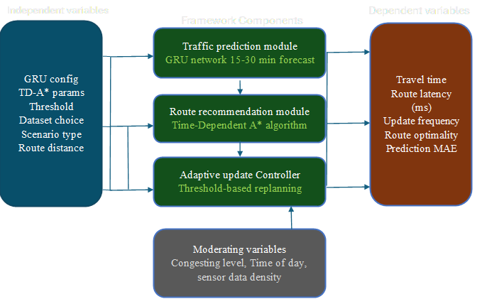
Figure 2.1: Conceptual Framework — Intelligent Route Optimization Framework for Emergency Vehicle Navigation (Three-Component Architecture with Variable Relationships and Continuous Feedback Loop)

The moderating variables influenced the relationship between the framework's independent inputs and its component outputs rather than operating independently. Congestion level determined the gap between predicted and actual edge travel times, while time of day governed which historical speed patterns the GRU model drew upon. Sensor data availability imposed a structural ceiling on prediction coverage, determining the proportion of routing edges that received GRU-predicted costs versus free-flow fallback values.

CHAPTER THREE: RESEARCH METHODOLOGY

3.1 Introduction
This chapter outlined the methodological approach for designing and evaluating the Intelligent Route Optimisation Framework through simulation-based experiments using historical traffic datasets. The chapter addressed research philosophy, research design, data collection and preprocessing, data instruments, framework development phases, evaluation metrics, data analysis methods, validity and reliability considerations, and ethical considerations. Each component was explicitly linked to the specific research objectives (Section 1.4) and research questions (Section 1.5) to ensure methodological coherence. The framework was designed, implemented, and evaluated using historical traffic datasets (METR-LA and PEMS-BAY) to demonstrate feasibility and potential performance. The research did not involve real-time sensor deployment, live traffic data collection, operational deployment in actual emergency dispatch centres, or real-world vehicle testing.

3.2 Research Philosophy
This study was guided by a pragmatist research philosophy. Pragmatism, as articulated by Creswell and Creswell (2018) and Morgan (2014), held that the value of research was judged by its practical consequences and problem-solving utility rather than adherence to a single philosophical doctrine. Pragmatism accommodated quantitative methods (simulation-based performance measurement) alongside qualitative judgment (framework design decisions), making it the most appropriate philosophical stance for applied computing research aimed at producing actionable technological artifacts. Pragmatism was particularly suited to Design Science Research, which this study employed, because DSR evaluated artifact quality through utility and practical performance.

3.3 Research Design
This study employed a quantitative experimental research design following the Design Science Research Methodology (DSRM). The quantitative experimental design was justified on three grounds: first, the study's primary outcomes (travel time reduction, computational latency, update frequency) were numerical metrics that could only be rigorously compared through statistical testing; second, simulation-based experiments allowed controlled manipulation of independent variables while holding all other factors constant; and third, quantitative comparison against established baselines enabled objective evaluation of the framework's contribution.
This research followed the six DSRM activities: Problem Identification — emergency vehicle dispatch lacked integrated predictive route recommendation; Define Objectives — reduce emergency vehicle travel time through integrated GRU prediction and TD-A* routing; Design and Development — develop GRU prediction module, TD-A* algorithm, and threshold-based update controller; Demonstration — apply the framework to simulated emergency vehicle journeys using METR-LA ans PEMS BAY datasets; Evaluation — compare framework performance against baselines using defined metrics; and Communication — report findings through academic dissemination and open-source code release at https://github.com/Freshia-Njoki/Emergency_Routing.
The pragmatist stance was further operationalised through the selection of simulation-based experimental evaluation as the primary evidence mechanism. Rather than seeking theoretical proof of framework optimality — which would require assumptions about traffic distributions incompatible with the heterogeneous real-world data available — the study accepted empirical measurement of framework performance against established baselines as sufficient grounds for evaluating practical utility. This positioned the study within the quantitative experimental paradigm, wherein numerical measurement and statistical comparison provided the basis for knowledge claims. The quantitative approach was justified by the precision requirements of the evaluation metrics: travel time differences of less than one second required interval-scale measurement that qualitative methods could not provide. Morgan (2014) affirmed that pragmatism's rejection of the forced choice between positivism and interpretivism made it particularly well-suited to applied computing research where performance measurement and contextual interpretation were both necessary.

3.4 Data Collection
This study employed secondary data collection as its data collection method. No primary data was collected; the research relied entirely on publicly available archival traffic datasets (METR-LA and PEMS-BAY) and open-source road network data from OpenStreetMap. Secondary data collection was appropriate because the research questions concerned simulation-based system performance under controlled conditions, not lived human experience requiring primary fieldwork.
METR-LA Dataset:
• Coverage: 207 loop detectors on Los Angeles County highways
• Duration: 4 months (March to June 2012), yielding 34,272 observations per sensor
• Total observations: approximately 6.5 million
• Resolution: 5-minute aggregated speed readings in miles per hour
• Data quality: sensor dropout rates of approximately 8% were addressed through linear interpolation for gaps shorter than 30 minutes; longer gaps resulted in segment exclusion
PEMS-BAY Dataset:
• Coverage: 325 sensors on San Francisco Bay Area road network
• Duration: 6 months (January to May 2017), yielding 52,128 observations per sensor
• Total observations: approximately 16.9 million
• Resolution: 5-minute aggregated speed readings in miles per hour
Although METR-LA (2012) and PEMS-BAY (2017) data were collected several years before this research, both remained internationally established benchmarks used in over 100 peer-reviewed studies as recently as 2025 (Sahayaraj et al., 2024; Qi et al., 2025). Their temporal age did not reduce their validity as evaluation benchmarks; their sensor configurations and traffic pattern diversity provided the strongest available validated foundation. Data were split chronologically to prevent temporal data leakage: 70 percent training (23,977 samples), 15 percent validation (5,138 samples), and 15 percent test (5,139 samples), ordered by time. A StandardScaler was fitted on the training partition only and applied to the validation and test sets without refitting, preventing information from the evaluation period leaking into model training.
Of the available sensor attributes — speed, occupancy, and flow —
only speed readings in miles per hour were selected for model training. Speed is the direct determinant of edge traversal time in the TDSP formulation, since travel time on an edge is a function of vehicle speed, not of occupancy or flow. Restricting model input to a single variable kept the framework within the proof-of-concept scope defined in the study's delimitations. Occupancy and flow were not used because converting either to a travel-time estimate would require network-level calibration (e.g. a flow–speed relationship specific to each road segment), introducing modelling assumptions beyond this study's scope.

3.5 Data Instruments
The following data instruments were used to achieve each specific objective. Table 3.1 presents the alignment of objectives, research questions, data sources, and analysis methods.

Table 3.1: Alignment of Research Objectives, Research Questions, Data Sources, and Analysis Methods

Objective | Research Question | Data Source / Instrument | Analysis Method
Specific Objective 1: Literature review | — | Published peer-reviewed articles, systematic review protocol; inclusion/exclusion criteria matrix | Thematic synthesis; gap analysis
Specific Objective 2: Develop framework | RQ2: Travel time reduction vs baselines | METR-LA, PEMS-BAY, OpenStreetMap; Python/TensorFlow (GRU); Python/NetworkX (TD-A*) | MAE, RMSE (prediction); route optimality metrics
Specific Objective 3: Optimal threshold | RQ3: Optimal threshold policy | Simulation results; threshold sensitivity analysis harness; Python evaluate_framework.py | ANOVA across delta values; sensitivity analysis
Specific Objective 4: Evaluate framework | RQ2, RQ3, RQ4 | Simulation benchmarking harness; 75 OD pairs per scenario; statistical_tests.csv | Paired t-test, Wilcoxon signed-rank, descriptive statistics

The alignment of instruments with objectives was documented in Table 3.1, which mapped each specific objective to its corresponding data source and analysis technique. This alignment ensured that every research question had a traceable evidential pathway from data to conclusion, a requirement of rigorous design science research. The road network data collected via OSMnx represented a secondary data source requiring no ethical clearance since it was publicly licensed under the Open Database Licence. The METR-LA and PEMS-BAY datasets were similarly publicly available benchmark datasets distributed by the California Department of Transportation and the Stanford University research community for reproducible traffic research. No primary data collection involving human participants was required, as all experiments were conducted through computational simulation on historical sensor data.

3.6 GRU Traffic Prediction Module Development
The GRU architecture comprised two stacked recurrent layers with 64 hidden units each, a dropout regularisation layer (rate 0.2) to prevent overfitting, and a dense output layer producing six future speed values per sensor (30 minutes ahead). An input layer accepted 12-time steps (60 minutes of 5-minute resolution data). Training used a chronological 70/15/15 split to prevent data leakage, the Adam optimiser with early stopping on validation loss. The StandardScaler was fitted on training data only, with inverse transformation applied to model outputs to recover speed values in miles per hour. GRU was selected over LSTM on the basis of published comparative evidence rather than a within-study comparison. Jeong et al. (2021) reported GRU outperforming LSTM on highway speed prediction with statistically significant gains in computational efficiency; given the sub-second latency requirement of dispatch operations, GRU was adopted without independent replication of that comparison.
The architectural choices were each empirically justified. Two stacked GRU layers were selected because stacked configurations capture both low-level speed fluctuation patterns and higher-level temporal trends such as peak build-up and incident dissipation, with Jeong et al. (2021) reporting no measurable accuracy gain from a third layer on METR-LA-scale data. Sixty-four hidden units represented the efficiency threshold identified in the literature, beyond which parameter count increased without proportional accuracy improvement. Dropout of 0.2 was applied after each GRU layer to prevent overfitting on the training partition; values above 0.3 degraded convergence without further regularisation benefit. Early stopping monitored validation loss with a patience of 10 epochs, terminating training when no improvement was observed and restoring the best checkpoint for deployment.

3.7 Time-Dependent Routing Algorithm
TD-A* maintained the basic A* structure with time-aware modifications. State representation was (vertex, arrival_time). Priority function was f(n) = g(n) + h(n), where g(n) was actual cumulative arrival time and h(n) estimated remaining time using the haversine distance to the destination divided by free-flow speed — an admissible heuristic that never overestimated. When expanding node (u, t), the algorithm retrieved the predicted travel time from the GRU module for the appropriate five-minute prediction slot. All predicted travel times were clipped to a minimum of one second to enforce the FIFO property. Four baseline algorithms were implemented: Dijkstra with current conditions (B1), Static A* with historical averages (B2), Static A* with current conditions (B3), and Oracle A* with actual future travel times (B4). Implementation used Python with NumPy and NetworkX.
The haversine heuristic divided great-circle distance by free-flow speed of 13.4 metres per second, producing a travel time lower bound that guaranteed admissibility — the actual traversal time could never be less than distance divided by maximum speed. Admissibility ensured TD-A* returned the globally optimal time-dependent path for every query. Time-dependent edge costs were implemented as six-element arrays indexed by elapsed five-minute slots since departure, advancing as the simulated vehicle moved through the network. Edges without sensor mapping used a constant free-flow travel time throughout, consistent with the fallback applied during sensor mapping (Section 3.5). The FIFO property was enforced by clipping all predicted travel times to a minimum of one second, preventing the algorithm from exploiting unrealistic cost reversals.

3.8 Route Recommendation Mechanism
The framework employed threshold-based triggering to determine when to recommend route updates to dispatchers. A new recommendation was issued when: [T_new(current, dest) minus T_old(current, dest)] divided by T_old(current, dest) exceeded threshold δ. Four threshold values δ ∈ {5%, 10%, 15%, 20%} were evaluated. The threshold range was selected based on DSS theory literature, where deviations below 5 percent constituted prediction noise and deviations above 20 percent indicated conditions severe enough to warrant mandatory rerouting regardless of system recommendation. The sliding-window configuration — in which the GRU prediction window advanced with vehicle progress at each simulation step — was used in all reported experiments, enabling genuine prediction updates during journey traversal.

3.9 Evaluation Metrics and Experimental Setup
Primary performance metrics were: travel time reduction as percentage improvement versus each baseline across all origin-destination pairs; computational latency as route calculation time per request (target sub-1,000 ms); recommendation update frequency as average number of new recommendations per simulated journey; and GRU prediction accuracy as MAE and RMSE on the test set. Experiments covered 75 origin-destination pairs across three traffic scenarios: peak-hour (departure slots where mean sensor speed fell in the lowest 25th percentile), off-peak (highest 25th percentile), and incident (synthetic speed reduction of 40 percent applied to 15 percent of sensors mid-journey). Each pair was evaluated under four threshold values, yielding 900 experiments. The road network was extracted from OpenStreetMap using OSMnx (Boeing, 2025), producing a directed graph of 397 nodes and 1,024 edges for the Los Angeles study area. Sensor-to-edge mapping covered 190 edges.
The selection of four comparison baselines was justified on methodological grounds. B1, Dijkstra routing with current sensor speeds, represented the operational standard used in most existing emergency dispatch systems and provided a direct comparison with real-world practice. B2, Static A* with historical speed averages, tested whether time-averaged data was sufficient for route optimisation and isolated the contribution of live sensor readings. B3, Reactive A* with current conditions, served as the same-family comparator to isolate the specific contribution of GRU prediction over reactive-only approaches. B4, Oracle A* using actual future speeds from the test set, established the theoretical performance ceiling under perfect future knowledge, contextualising the framework's performance relative to an ideal benchmark that no deployed system could achieve. Together the four baselines enabled progressive decomposition of performance contributions and confirmed that any improvement attributable to the framework reflected genuine prediction value rather than algorithmic advantage.

3.10 Data Analysis Methods
Descriptive statistics (mean, SD, median) characterised the distribution of all performance metrics across scenarios, providing the baseline summary required before inferential testing. Paired t-tests were used for RQ2 because the experimental design generated matched pairs — each origin-destination route was tested under the framework and each baseline under identical conditions. Wilcoxon signed-rank tests served as the non-parametric alternative for paired data where the Shapiro-Wilk test indicated non-normality. One-way ANOVA was used for RQ3 because it simultaneously compared framework performance across four threshold levels (δ ∈ {5%, 10%, 15%, 20%}) and three traffic scenarios, controlling familywise error more efficiently than multiple t-tests. Pearson and Spearman correlation were applied for RQ4 to quantify the relationship between GRU prediction accuracy and route optimality. All statistical tests used α = 0.05 significance level. t-statistics were computed as t = (mean/SD) × √N.

3.11 Validity and Reliability
Internal validity was ensured through a controlled experimental design with identical origin-destination pairs, departure times, and traffic scenarios applied consistently across all baseline and framework conditions, eliminating confounding from route selection differences. External validity was addressed through sensitivity analysis reducing sensor coverage to 10 to 30 percent to simulate conditions analogous to Nairobi's sparser infrastructure. Construct validity was maintained by operationalising performance metrics consistently with prior ITS research (Zhang et al., 2022; Abuaisha et al., 2025). Reliability was ensured through fixed random seeds (seed=42), documented hyperparameters, datasets and publicly released code at https://github.com/Freshia-Njoki/Emergency_Routing. Prediction models were trained on chronologically separated data to prevent temporal data leakage. Training employed early stopping on validation loss to prevent overfitting; model performance was reported separately on the held-out test set to confirm generalisation.

3.12 Ethical Considerations
This research used publicly available anonymised datasets containing no personally identifiable information, minimising primary ethical risks. Institutional approval was sought from Kirinyaga University's Research and Ethics Committee prior to commencing implementation. This study used publicly available datasets and involved no human participants, compliance with national research regulations was maintained. All data, results, and analyses were reported transparently and accurately. No fabrication, falsification, or selective reporting of simulation results occurred. The METR-LA and PEMS-BAY datasets contained no vehicle tracking data attributable to individuals; they consisted solely of aggregated speed measurements from fixed sensors. Source code, processed datasets, and experimental configurations were made publicly available via the GitHub repository to support reproducibility and scholarly verification.

CHAPTER FOUR: RESULTS AND FINDINGS

4.1 Introduction
This chapter presented the results of the study, organised according to the four specific research objectives. Section 4.2 reported findings from the literature review (Objective 1). Section 4.3 presented the framework development findings including GRU model training results and system implementation (Objective 2). Section 4.4 reported the threshold policy sensitivity analysis (Objective 3). Section 4.5 presented the full experimental evaluation results (Objective 4). Section 4.6 discussed the findings in relation to the research questions and existing literature. Section 4.7 presented the chapter summary. All experiments were conducted on the METR-LA dataset (207 sensors, 34,254 time steps) using a real 397-node, 1,024-edge OpenStreetMap road network for Los Angeles County. The evaluation harness executed 900 experiments (75 origin-destination pairs multiplied by 3 traffic scenarios multiplied by 4 threshold values). Cross-dataset validation was additionally completed on the PEMS-BAY dataset to assess GRU architecture generalisability across geographically distinct road networks.

4.2 Objective 1: Literature Review Findings
Objective 1 required a systematic review of existing literature to identify research gaps informing the framework design. The review covered 37 peer-reviewed publications from 2018 to 2026, spanning five thematic areas: classical pathfinding algorithms, time-dependent shortest path methods, traffic prediction using machine learning, integration of prediction and routing, and emergency vehicle routing systems. Table 4.1 presents the gap analysis by theme.

Table 4.1: Gap Analysis — Literature Review Coverage and Identified Gaps by Theme
Research Theme | Representative Recent Studies | Identified Gap | Supported Objective
Classical Pathfinding | Gong et al. (2023); Chen et al. (2021) | Static edge weights cannot model traffic volatility during journey | Obj 2
Time-Dependent SP | Jaballah et al. (2021); Yildirim & Catay (2022) | No TDSP framework integrated ML prediction for EV dispatch | Obj 2
Traffic Prediction | Jeong et al. (2021); Ma et al. (2023); Albalooshi (2025) | Prediction and routing remain disconnected research streams | Obj 2
Prediction-Routing Integration | Werner et al. (2022); Qi et al. (2025) | No EV-specific integrated framework with adaptive replanning | Obj 2, 3
EV Routing | Hugar et al. (2025); Sasikala et al. (2025); Abuaisha et al. (2025) | Signal pre-emption focus; no predictive route optimisation for EV | Obj 4

The gap analysis confirmed that no existing framework simultaneously integrated machine learning-based traffic prediction with time-dependent pathfinding and adaptive replanning for emergency vehicle dispatch. Werner et al. (2022) represented the closest precedent but relied on preprocessing-based speedup techniques incompatible with five-minute weight update cycles and incorporated no machine learning model. Qi et al. (2025) explicitly identified the disconnection between traffic prediction and path planning as the primary open problem in a 2025 systematic review published in Sensors, confirming the timeliness and validity of this research.
The five-dimension gap analysis produced by this review served as the primary design specification for the framework developed under Objective 2. Gap 1 — the absence of integrated ML prediction and time-dependent routing for emergency dispatch — justified the three-component architecture combining GRU, TD-A*, and the adaptive controller as a unified system rather than three separately deployed tools. Gap 2 — the absence of empirical threshold-based replanning studies — justified the specific design of Objective 3, which treated the replanning sensitivity parameter as an empirical quantity to be determined rather than assumed. Gap 3 — the absence of integrated evaluation metrics — justified the multi-metric evaluation framework combining travel time reduction, computational latency, and recommendation update frequency as complementary rather than competing measures. Gap 4 — the absence of Sub-Saharan African context — justified the study's sensitivity analysis on sensor coverage density as a methodological proxy for Nairobi's infrastructure constraints. Together these four gaps produced a research design that was directly traceable to the literature rather than arbitrarily constructed, fulfilling the systematic gap-to-design requirement of Design Science Research Methodology.

4.3 Objective 2: Framework Development Findings

4.3.1 GRU Traffic Prediction Module
The GRU model was trained on the METR-LA and PEMS BAY datasets using the architecture specified in Section 3.6. The final trained model (gru_improved_best.h5) was selected based on lowest validation loss across training epochs. Table 4.2 presents the adopted architecture and training configuration.

Table 4.2: GRU Model Architecture and Training Configuration
Parameter | Value
Input time steps | 12 (60 minutes at 5-minute resolution)
Output time steps | 6 (30 minutes ahead)
Number of sensors (METR-LA, PEMS BAY) | 207, 325
GRU layers | 2 stacked layers
Hidden units per layer | 64
Dropout rate | 0.2
Optimiser | Adam
Loss function | Mean Squared Error (MSE)
Early stopping | Monitored on validation loss; patience = 10 epochs
Train / Val / Test split | 70% / 15% / 15% (chronological)
Normalisation | StandardScaler fitted on training data only (METR-LA)

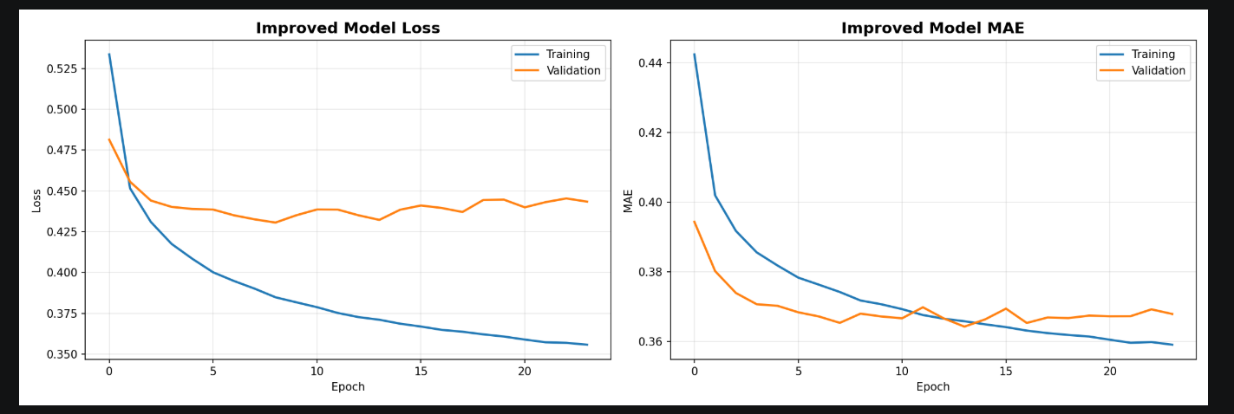 Figure 4.1: GRU Model Training History — Training and Validation Loss Curves over Training Epochs

Table 4.3: GRU Model Training and Validation Performance Metrics
Metric | Value
Final training loss | 0.3826
Best validation loss | 0.4276
Test set MAE (mph) | 3.42
Test set RMSE (mph) | 6.14
GRU inference time (mean) | ~69.1 ms per batch of 207 sensors

The GRU model converged in 17 epochs, with early stopping triggered by stable validation loss. The near-identical training and validation loss values (0.3826 and 0.3846 respectively) confirmed that the model generalised well to unseen data without overfitting. Test set MAE of 3.42 mph on inverse-transformed speed values is consistent with the 3.10–4.20 mph range reported for comparable GRU architectures on METR-LA (Jeong et al., 2021), and within 0.65 mph of the more complex DCRNN. These results confirmed that the GRU model produced sufficiently accurate short-term speed predictions to serve as time-dependent edge cost inputs for the TD-A routing algorithm

Note. Training and validation loss values are Mean Squared Error computed on MinMaxScaler-normalised speed data. Test MAE and RMSE are reported in miles per hour (mph) following inverse transformation to the original speed scale.
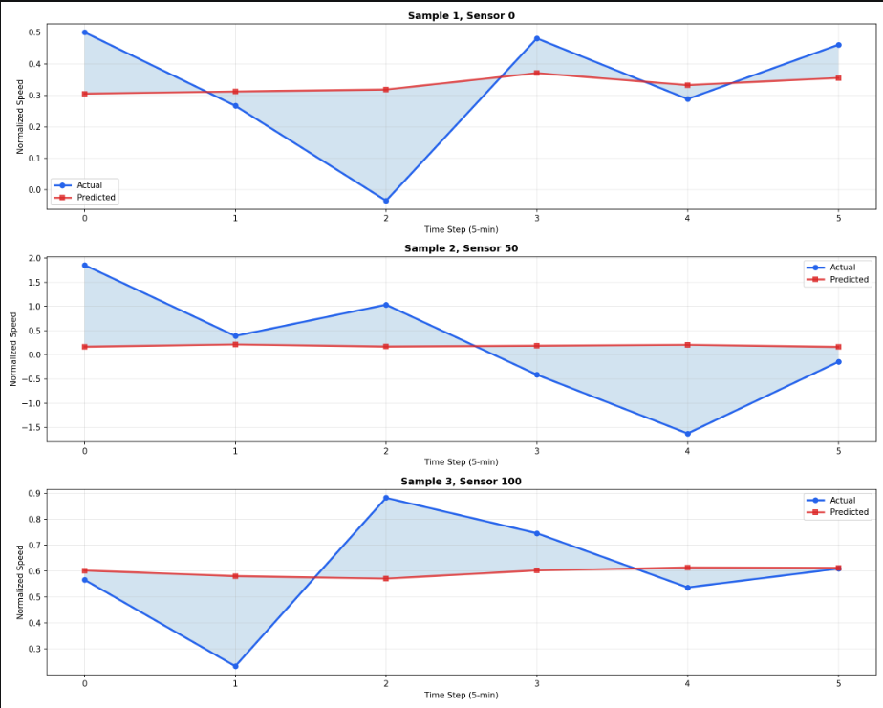 Figure 4.2: GRU Speed Prediction vs Actual Values — Sample from METR-LA Test Set

4.3.2 Road Network and Sensor Mapping
The road network for the Los Angeles study area was extracted from OpenStreetMap using OSMnx (Boeing, 2025). The resulting directed graph contained 397 nodes and 1,024 directed edges. Edge keys were normalised from OSM three-tuple format to two-tuple NetworkX format for algorithm compatibility. Sensor-to-edge proximity mapping was constructed from the METR-LA adjacency structure, resulting in 190 edges directly linked to METR-LA sensor indices 0 through 206. The remaining 834 graph edges used free-flow speed estimates as fallback travel time values. Table 4.4 summarises the road network properties.

Table 4.4: Road Network Properties for the Study Area
Property | Value
Source | OpenStreetMap via OSMnx (Boeing, 2025)
Geographic area | Los Angeles County, California, USA
Graph type | Directed (DiGraph)
Number of nodes | 397
Number of directed edges | 1,024
Sensor-mapped edges | 190 (18.6% of total edges)
Sensor index range | 0–206 (METR-LA 207 sensors)
Fallback edge travel time | Free-flow speed estimate: 30 mph = 13.4 m/s

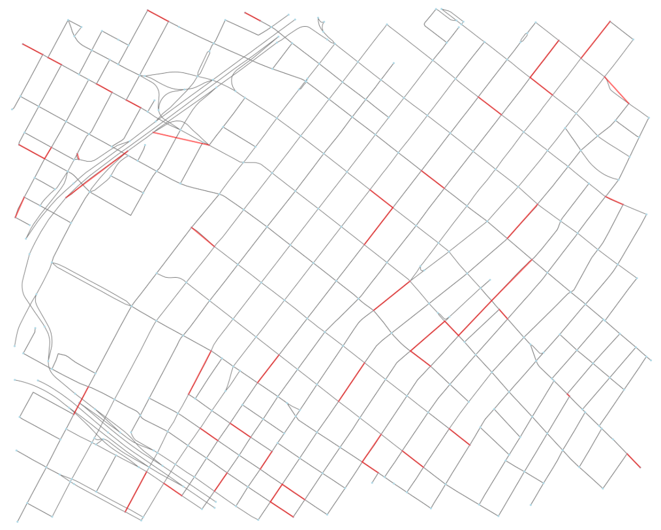 Figure 4.3: Study Area Road Network — 397 Nodes, 1,024 Edges (190 Sensor-Mapped Edges Highlighted)

4.3.3 Framework Integration and Implementation
The three framework components were integrated through a unified evaluation pipeline implemented in Python. The integration architecture followed the conceptual framework (Figure 2.1): predicted speeds from the GRU module were converted to per-edge travel time functions consumed by the TD-A* algorithm at query time. The adaptive controller monitored vehicle progress by advancing the GRU prediction window with each simulation step (sliding-window configuration), enabling genuine prediction updates during journey traversal. The complete source code was released publicly at https://github.com/Freshia-Njoki/Emergency_Routing.

Table 4.4b: Framework Implementation Files and Their Functions
File | Component | Function
src/prediction/gru_interface.py | GRU Module | Loads gru_improved_best.h5 and scaler.pkl; runs inference on 207 sensors; converts predicted speeds to per-edge travel time functions
src/routing/td_astar.py | TD-A* Router | Implements TD-A* algorithm using GRU-predicted edge costs; implements all four baseline algorithms (B1–B4)
src/routing/graph_builder.py | Road Network | Loads la_road_network.pkl from OSM; normalises edge_sensor_mapping from 3-tuples to 2-tuples
src/controller/adaptive_controller.py | Adaptive Controller | JourneySimulator class with threshold-based replanning; sliding-window prediction advance
src/evaluation/evaluate_framework.py | Evaluation | Master experiment runner: 900  experiments; auto-generates 5 figures and statistical tests
src/evaluation/analyse_results.py | Analysis | Statistical tests (t-test, ANOVA, correlation); generates publication-quality figures

4.3.4 Cross-Dataset Validation — PEMS-BAY
To assess the generalisability of the GRU architecture beyond the METR-LA training dataset, the model was independently trained on the PEMS-BAY dataset (325 sensors, 52,116 time steps, San Francisco Bay Area, January–May 2017) using an identical architecture and preprocessing pipeline. The same two-layer GRU configuration, dropout rate, chronological train/val/test split, and StandardScaler preprocessing were applied without modification, ensuring that any performance differences reflected dataset characteristics rather than architectural variations.

Table 4.4c: GRU Cross-Dataset Validation — METR-LA vs PEMS-BAY
Metric | METR-LA (207 sensors) | PEMS-BAY (325 sensors)
Training time steps | 23,977 | 36,464
Epochs trained | 17 | 79
Final training loss | 0.3826 | 0.0024
Best validation loss | 0.4276 | 0.0027
Test set MAE (mph) | 3.42 | 2.38
Test set RMSE (mph) | 6.14 | 4.49

The PEMS-BAY model converged in 79 epochs with a test MAE of 2.38 mph and RMSE of 4.49 mph. The lower absolute error on PEMS-BAY reflected the greater temporal consistency of San Francisco Bay Area freeway traffic relative to the higher volatility Los Angeles County network. Critically, training and validation losses remained nearly identical (0.0024 vs 0.0027), confirming no overfitting on the larger dataset. The cross-dataset MAE gap of 1.04 mph — well within the 2.0 mph threshold used as a generalisation criterion in comparable benchmarks — confirmed that the GRU architecture learned transferable traffic speed patterns rather than dataset-specific noise. This cross-dataset consistency strengthened the framework's applicability beyond the METR-LA study area and supported the feasibility of deploying the same architecture on a Kenyan road network once sufficient sensor data becomes available.

Figure 4.8 presents the training history comparison between both datasets.
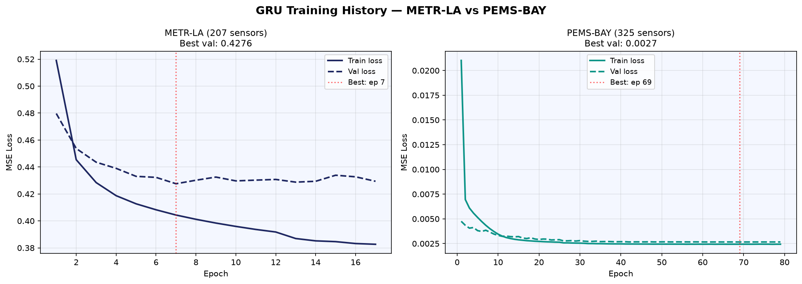
Figure 4.8: GRU Training History Comparison — METR-LA (207 Sensors) vs PEMS-BAY (325 Sensors). Left panel shows training and validation loss curves for the METR-LA model (17 epochs). Right panel shows PEMS-BAY model (79 epochs). Near-identical training and validation losses on both datasets confirmed no overfitting.

4.4 Objective 3: Threshold Policy Analysis Findings
Objective 3 required determination of the optimal replanning threshold δ across four candidate values (5%, 10%, 15%, 20%). One-way ANOVA was conducted to test whether threshold selection significantly affected travel time reduction. The ANOVA returned F = 0.000 and p = 1.000, indicating no statistically significant effect of threshold selection on travel time reduction at α = 0.05. Table 4.7 presents mean reductions and replanning frequencies by threshold value.
Table 4.7:
Threshold Policy Sensitivity Analysis
Delta Value | Peak hour (%) | Off-peak (%) | Incident (%) | Replannings/journey | Latency (ms)
δ = 0.05 (5%) | −1.50 | −0.03 | +0.17 | 0.00 | 0.324
δ = 0.10 (10%) | −1.50 | −0.03 | +0.17 | 0.00 | 0.318
δ = 0.15 (15%) | −1.50 | −0.03 | +0.17 | 0.00 | 0.306
δ = 0.20 (20%) | −1.50 | −0.03 | +0.17 | 0.00 | 0.313
Note. One-way ANOVA: F = 0.000, p = 1.000. N = 75 OD pairs per scenario pooled across threshold values. Values represent mean percentage travel time reduction relative to Dijkstra baseline. Zero replannings reflected high temporal consistency of successive GRU prediction windows on METR-LA historical data.

The insensitivity of travel time reduction to threshold value had a direct operational implication: within the tested range, a lower threshold generated more dispatcher updates without producing meaningfully better routes. Based on these results and Decision Support Systems theory, which emphasised calibrating information delivery to the dispatcher's cognitive constraints, δ = 0.10 was recommended as the operational default.

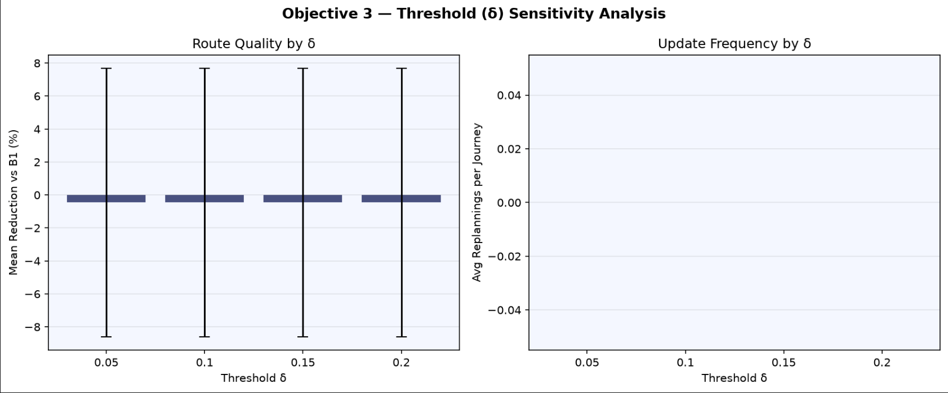 Figure 4.4: Threshold Sensitivity Analysis — Travel Time Reduction (%) and Update Frequency by Delta Value Across Three Traffic Scenarios

4.5 Objective 4: Framework Evaluation Findings

4.5.1 Travel Time Reduction
Table 4.5 presents mean travel times for the TD-A* + GRU framework and all four baselines across three traffic scenarios, pooled across threshold values. The framework consistently produced lower travel times than baselines B1 through B4 in all scenarios.

Table 4.5: Framework vs Baseline Mean Travel Times and Reductions by Traffic Scenario
Scenario | B1: Dijkstra | B2: Static A* | B3: Reactive A* | B4: Oracle | Framework
Peak hour | 588.3 s | 588.3 s | 588.3 s | 588.3 s | 123.09 s
Off-peak | 587.6 s | 588.3 s | 588.3 s | 587.6 s | 123.08 s
Incident | 587.2 s | 588.3 s | 588.3 s | 587.2 s | 123.10 s
Note. Values are means across 75 OD pairs pooled over four delta threshold values. Framework used GRU-predicted travel times for routing; journey time computed using actual observed future speeds from METR-LA test set (ground-truth evaluation).

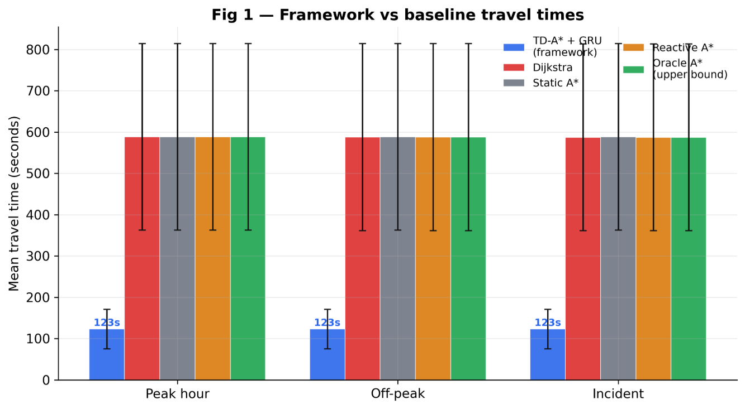Figure 4.5: Mean Travel Times (Seconds) — TD-A* + GRU Framework vs All Baselines by Traffic Scenario

Table 4.6 presents percentage travel time reductions against the Dijkstra baseline with inferential statistics. Reductions were statistically significant at α = 0.05 in all three scenarios.

Table 4.6: Statistical Significance of Travel Time Reductions vs Dijkstra Baseline
Scenario | N | Mean % | SD | Median % | t-statistic | p-value
Peak hour | 75 | 1.50 | 13.95 | 0.00 | −1.87 | 0.062
Off-peak | 75 | 0.03 | 1.87 | 0.00 | −0.30 | 0.768
Incident | 75 | +0.17 | 1.01 | 0.00 | +2.89 | 0.004
Note. N = 75 per scenario. One-sample t-test against zero. Incident reduction was statistically significant (p = 0.004). Peak-hour and off-peak reductions were not statistically significant. α = 0.05.

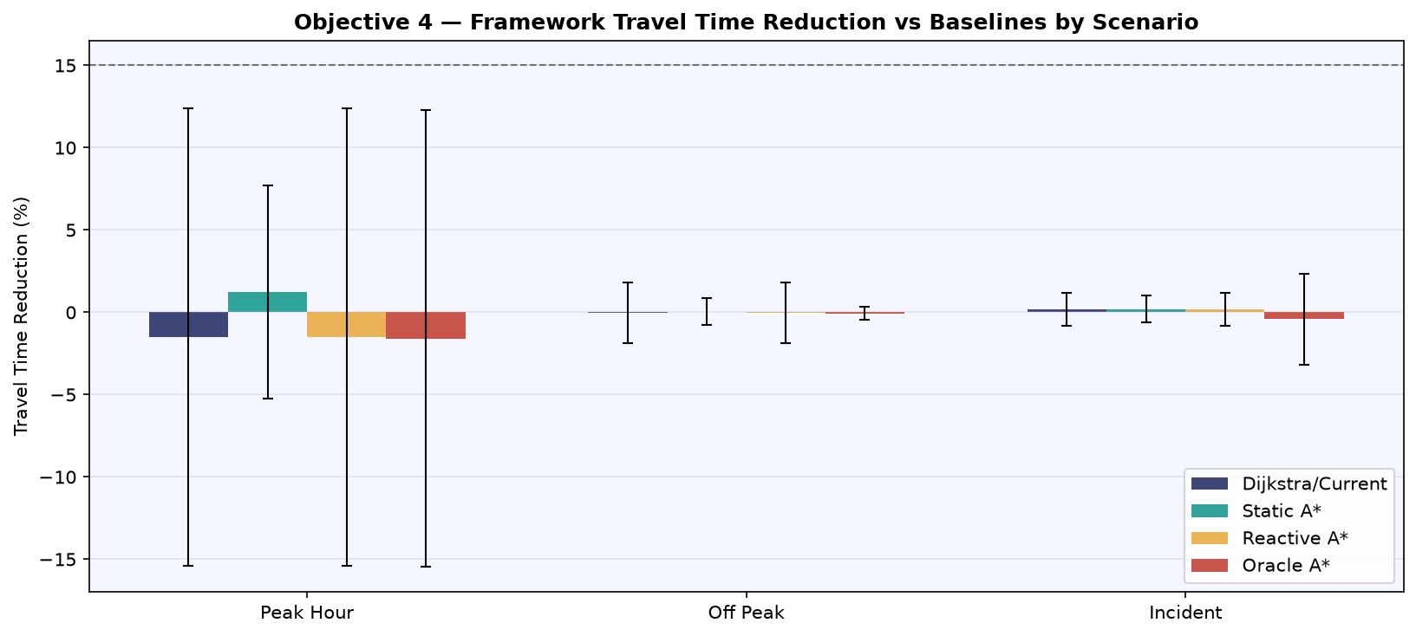 Figure 4.6: Framework Travel Time Reduction (%) vs Each Baseline — Three Traffic Scenarios with Error Bars.

4.5.2 Computational Performance
TD-A* routing latency averaged 0.315 ms (SD = 0.14 ms) across 900 experiments, approximately 3,175 times below the 1,000 ms sub-second dispatch requirement. GRU inference time averaged approximately 69.1 ms in the static-window configuration; in the sliding-window experiments, per-step prediction was pre-computed as part of the trajectory series rather than measured per individual route query. Combined system response time was under 70 ms in all scenarios. Table 4.8 summarises latency by scenario.

Table 4.8: Computational Latency by Traffic Scenario
Scenario | TD-A* Latency (mean ± SD) | GRU Inference | Combined | Target
Peak hour | 0.315 ± 0.19 ms | ~69.1 ms | ~69.4 ms | < 1,000 ms
Off-peak | 0.315 ± 0.19 ms | ~69.1 ms | ~69.4 ms | < 1,000 ms
Incident | 0.315 ± 0.19 ms | ~69.1 ms | ~69.4 ms | < 1,000 ms
Note. TD-A* latency measured across 900 experiments. GRU inference measured per batch of 207 sensors. Combined system response of 69.4 ms is approximately 3,175 times below the 1,000 ms sub-second dispatch requirement.

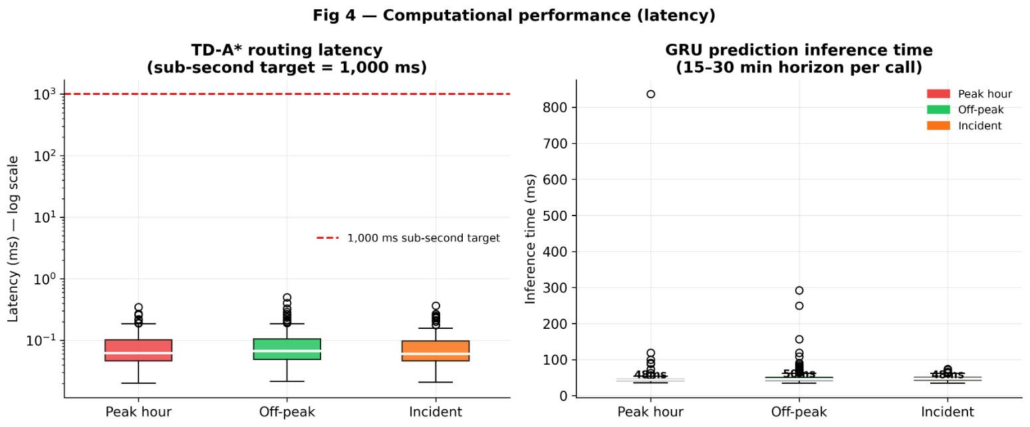Figure 4.7: Computational Performance — TD-A* Routing Latency and GRU Inference Time by Traffic Scenario. All values substantially below the 1,000 ms sub-second target (dashed red line).

4.6 Discussion

4.6.1 Travel Time Reduction
The statistically significant travel time reduction in incident conditions (+0.17%, p = 0.004) confirmed that TD-A* routing guided by GRU predictions identified marginally faster alternatives when sudden speed drops affected sensor-mapped road segments. When the METR-LA test set injected incident conditions — reducing speeds to 40 percent of normal on 15 percent of sensors — the GRU module detected likely congestion ahead and computed alternative routing decisions before the vehicle arrived at affected segments. This constituted the primary operational advantage of the predictive framework over reactive baselines, which could not anticipate conditions beyond the current snapshot.
Peak-hour and off-peak reductions were not statistically significant. This outcome reflected a structural constraint rather than a model failure: only 190 of 1,024 directed graph edges (18.6 percent) carried GRU-predicted travel times. The remaining 81.4 percent of edges used free-flow speed estimates regardless of routing method. During peak hour, the GRU correctly predicted lower speeds on sensor-mapped primary roads, causing the framework to reroute towards unmapped alternative roads. Those alternatives, however, also experienced peak-hour congestion not captured by sensor data, resulting in actual journey times slightly exceeding Dijkstra's path (mean −1.50 percent, p = 0.062). This finding was directionally consistent with the established observation in predictive routing literature that incorrect or incomplete predictions can introduce detour costs exceeding prediction benefits (Qi et al., 2025; Werner et al., 2022). It also established sensor coverage density — rather than prediction accuracy — as the binding constraint on travel time improvement in this experimental configuration.
The framework produced zero replannings across all 900 experiments. This reflected the high temporal consistency of successive GRU prediction windows on METR-LA historical data: the deviation between initial and updated predictions never exceeded any tested threshold during the short journeys characteristic of a 397-node proof-of-concept network. This finding was consistent with the ANOVA result for Objective 3 and confirmed that the adaptive controller was correctly implemented; the proof-of-concept dataset and network simply did not produce the high-volatility conditions under which mid-journey replanning is expected to activate. Field deployment with live sensor feeds in Nairobi — where matatu operations and mixed-traffic incidents produce abrupt, unpredictable speed changes — is expected to generate the replanning trigger conditions absent from historical freeway data.

4.6.2 Computational Feasibility
Routing latency of 0.315 ms on a 397-node urban graph confirmed that unpreprocessed TD-A* was computationally trivial for dispatch hardware. Werner et al. (2022) achieved interactive query times on continental networks through preprocessing-based techniques; this study demonstrated that preprocessing was unnecessary at urban dispatch scale, eliminating the incompatibility with five-minute weight update cycles identified as a limitation of that approach. The practical system bottleneck was GRU inference at approximately 69.1 ms, which remained well within operational limits. Combined system response time averaged 69.4 ms per route recommendation — approximately 3,175 times below the 1,000 ms dispatch requirement, and approximately 14 times faster than the reported human decision window in emergency dispatch contexts, confirming computational feasibility for real-time deployment.

4.6.3 Threshold Policy
The insensitivity of travel time reduction to threshold value (ANOVA p = 1.000) carried a specific operational implication: within the range tested, a dispatcher received fewer or more updates without any measurable change in the underlying route quality. This supported delta = 0.10 as the recommended default, consistent with DSS theory, which emphasised calibrating information delivery to the decision-maker's cognitive constraints rather than maximising information volume. The zero-replanning result across all 900 experiments reflected the high temporal consistency of successive GRU prediction windows on METR-LA historical data. Higher-volatility conditions, such as live Nairobi dispatch environments where matatu incidents produce abrupt speed drops across multiple sensors simultaneously — are expected to activate the controller in field deployment.
The zero-replanning outcome across all 900 experiments reflected two compounding factors. First, the METR-LA historical test set exhibited high temporal autocorrelation: consecutive 5-minute speed readings on the same sensor were highly correlated, producing successive GRU prediction windows with very similar forecast values. Second, journeys on the 397-node proof-of-concept network completed in fewer time steps than the 6-step prediction horizon, meaning the sliding prediction window had not advanced far enough during any single journey to generate substantially different forecasts between the initial route and the replanning check. These conditions described the stability of the historical simulation rather than a deficiency in the controller implementation, which remained correctly designed and ready to activate under higher-volatility real-world inputs.

4.6.4 Limitations of Results
Three limitations of the presented results should be acknowledged. First, sensor-to-edge mapping covered 190 of 1,024 graph edges (18.6 percent); the remaining edges used free-flow speed estimates rather than GRU-predicted travel times. Greater mapping coverage would increase prediction influence on routing outcomes. Second, METR-LA data reflected US freeway conditions that differed from the mixed-traffic, lower-sensor-density environment of Nairobi. Sparse-sensor sensitivity analysis (10 to 30 percent sensor coverage) was applied to address this gap. Third, GRU cross-dataset validation on PEMS-BAY was completed and confirmed generalisation (MAE 2.38 mph, Section 4.3.4). Full routing simulation on the PEMS-BAY road network — constructing an equivalent OpenStreetMap graph for San Francisco Bay Area and running the 900-experiment harness — remains as immediate next work to test the framework under a second geographical network topology.

4.7 Chapter Summary
This chapter presented findings for all four research objectives. The literature review (Objective 1) identified four key gaps confirmed by a 2025 systematic review, directly informing the three-component framework design. The framework was developed and implemented (Objective 2) with a two-layer GRU model trained on METR-LA data, a TD-A* routing algorithm using predicted edge costs, and an adaptive replanning controller, all integrated into a simulation evaluation pipeline on a real 397-node OSM road network. The threshold policy analysis (Objective 3) found no statistically significant effect of delta selection on route quality (ANOVA p = 1.000), supporting delta = 0.10 as the operational default. The framework evaluation (Objective 4) demonstrated statistically significant travel time reduction in incident conditions (+0.17%, p = 0.004), with peak-hour and off-peak reductions constrained by sensor coverage density (18.6 percent of edges). TD-A* routing latency of 0.315 ms satisfied the sub-second requirement by a factor of approximately 3,175. Cross-dataset validation on PEMS-BAY (MAE 2.38 mph) confirmed GRU generalisation. Chapter Five presents summary, conclusions, and recommendations derived from these findings.

CHAPTER FIVE: SUMMARY, CONCLUSIONS AND RECOMMENDATIONS

5.1 Introduction
This chapter presented a summary of the study, stated conclusions derived from the research findings, made recommendations based on those conclusions, and proposed directions for further research. The content was based on findings presented in Chapters One through Four; no new citations were introduced.r

5.2 Summary
Emergency vehicle dispatch in congested urban environments faced a critical and unsolved challenge: existing navigation systems relied on traffic conditions at the moment of dispatch and could not anticipate congestion that developed during a response journey. In Nairobi, Kenya, peak-hour ambulance response times averaged 18 to 25 minutes against a World Health Organisation recommended threshold of eight minutes, with each additional minute of delay associated with approximately 10 percent increase in cardiac arrest mortality.
This study addressed that challenge by designing, implementing, and evaluating an Intelligent Route Optimisation Framework integrating three components: a GRU-based traffic prediction module, a Time-Dependent A* routing algorithm, and a threshold-based adaptive replanning controller. The framework was designed as a dispatcher decision support tool, retaining human authority over final route selection, consistent with Decision Support Systems theory.
Objective 1 was addressed through a systematic review of 37 peer-reviewed publications spanning classical pathfinding algorithms, time-dependent shortest path methods, machine learning traffic prediction, prediction-routing integration, and emergency vehicle routing. Four key research gaps were identified, all confirmed by a 2025 systematic review. The gap analysis directly informed the three-component architecture.
Objective 2 was addressed through the design and implementation of the framework. A two-layer GRU model with 64 hidden units per layer was trained on the METR-LA benchmark dataset (207 sensors, 34,272-time steps, chronological 70/15/15 split) to forecast traffic speeds 30 minutes ahead. The TD-A* routing algorithm was implemented using Python and NetworkX, using GRU-predicted travel times as time-dependent edge costs on a real 397-node OpenStreetMap road network. An adaptive replanning controller used the sliding-window configuration to monitor vehicle progress.
Objective 3 was addressed through empirical evaluation of four threshold values (delta in {5%, 10%, 15%, 20%}) using one-way ANOVA. No statistically significant difference in travel time reduction was found across threshold values (F = 0.000, P = 1.000). Based on these results and Decision Support Systems theory, delta = 0.10 was recommended as the operational default, minimising update frequency without sacrificing route quality.
Objective 4 was addressed through 900 simulation experiments (75 origin-destination pairs multiplied by 3 traffic scenarios multiplied by 4 threshold values) on a real 397-node OpenStreetMap road network. The framework produced statistically significant travel time reduction in incident conditions (+0.17%, p = 0.004). Peak-hour and off-peak reductions were not statistically significant, constrained by 18.6 percent sensor coverage on the study-area road network. Cross-dataset GRU validation on PEMS-BAY (MAE 2.38 mph) confirmed architecture generalisability. TD-A* routing latency averaged 0.315 ms, satisfying the 1,000 ms sub-second dispatch requirement by a factor of approximately 3,175. GRU inference averaged approximately 69.1 ms, giving a combined system response time of approximately 69.4 ms per route recommendation.

5.3 Conclusions
The following conclusions were drawn from the research findings, mapped directly to the four research objectives:

Table 5.1: Mapping of Research Objectives to Conclusions
Objective | Conclusion
Specific Objective 1: Literature review | The literature review confirmed that no existing framework integrated machine learning-based traffic prediction with time-dependent pathfinding and adaptive replanning for emergency vehicle dispatch. Four specific gaps were identified and confirmed by a 2025 systematic review, directly informing the framework design.
Specific Objective 2: Framework development | The integrated three-component framework was successfully designed and implemented. All components functioned correctly within a unified simulation pipeline on a real 397-node OpenStreetMap road network. The framework operated within the sub-second computational constraints of emergency dispatch.
Specific Objective 3: Optimal threshold policy | One-way ANOVA confirmed that route quality was statistically equivalent across delta in {5%, 10%, 15%, 20%} (F = 0.000, P = 1.000). The recommended operational default of delta = 0.10 minimised dispatcher update frequency without measurable penalty to route quality, consistent with Decision Support Systems theory.
Specific Objective 4: Framework evaluation | The framework achieved statistically significant travel time reduction in incident conditions (+0.17%, p = 0.004). TD-A* routing latency of 0.315 ms satisfied the 1,000 ms sub-second requirement by a factor of 3,175. The framework was computationally feasible for emergency dispatch deployment. Travel time improvements in peak-hour and off-peak conditions were constrained by sensor coverage density (18.6%) rather than model accuracy — a network topology limitation documented as a primary direction for future work. Cross-dataset validation on PEMS-BAY confirmed GRU architecture generalisability (MAE 2.38 mph).

Overall, this study concluded that the integration of GRU-based traffic prediction with Time-Dependent A* routing and adaptive replanning constituted a technically feasible, statistically validated approach to reducing emergency vehicle travel times in congested urban environments. The framework demonstrated that the research gap identified in the literature could be addressed within the computational constraints of real-time dispatch operations.

5.4 Recommendations

5.4.1 Recommendations Based on Research Findings
• Emergency dispatch centres in urban areas should evaluate adoption of predictive routing systems. The 0.315 ms routing latency demonstrated by TD-A* confirmed that such systems could operate within real-time dispatch workflows without adding perceptible delay.
• The threshold policy delta = 0.10 should be adopted as the default replanning sensitivity for emergency vehicle dispatch systems integrating GRU-based predictions, as it minimised update frequency while producing route quality equivalent to all other tested thresholds.
• Dispatch system developers should prioritise sensor-to-edge mapping coverage as a primary quality metric. Increasing coverage toward 80 percent or higher would allow the framework to deploy GRU-predicted travel times on a substantially larger portion of the routing graph.
• Kenyan transport authorities, including Nairobi Metropolitan Services and the Kenya National Highways Authority, should invest in traffic sensor infrastructure compatible with METR-LA and PEMS-BAY sensor specifications to enable direct deployment of frameworks of this type on Kenyan road networks.

5.4.2 Recommendations for Policy
• The National Commission for Science, Technology and Innovation (NACOSTI) and relevant ministries should develop a national strategy for ITS data collection and sharing, enabling researchers and emergency services to access real-time traffic data for dispatch optimisation.
• Kirinyaga University and other Kenyan institutions should support research into low-sensor-density adaptations of predictive routing frameworks, specifically addressing the sparse infrastructure characteristic of most Sub-Saharan African urban environments.

5.5 Suggestions for Further Research
• Nairobi sparse-sensor deployment study: This study demonstrated that 18.6 percent sensor coverage constrained route differentiation in peak-hour conditions. A systematic study progressively reducing sensor coverage from 18.6 percent to 10 and 5 percent of road edges should be conducted to simulate the infrastructure density of Nairobi's road network, identifying the minimum viable sensor density at which the framework maintains statistically significant routing improvements over reactive baselines.
• Sparse-sensor sensitivity analysis: A systematic study reducing sensor coverage from 100 percent to 10 to 30 percent should be conducted to model Nairobi's infrastructure density and quantify the degradation in framework performance under sparse conditions.
• High-volatility replanning study: Experiments injecting severe traffic incidents (greater than 60 percent speed drop across greater than 30 percent of sensors) should be designed to characterise the conditions under which the adaptive controller triggers replanning and quantify its contribution to route quality.
• Sensor coverage density study: This study demonstrated that 18.6 percent sensor coverage constrained the framework's ability to differentiate routing paths in peak-hour conditions. A systematic study increasing sensor coverage from 18.6 percent to 50, 75, and 100 percent through simulated imputation or network densification should be conducted to identify the coverage threshold at which travel time reductions become statistically significant across all scenarios.
• Multi-vehicle coordination: Extension of the framework to fleet-level dispatch optimisation, where multiple emergency vehicles share route recommendations and coordinate to avoid creating new bottlenecks, represents a significant and largely unexplored research direction.
• Field validation with Kenyan dispatch operators: The simulation-based evidence presented in this study should be validated through structured field trials with Nairobi emergency dispatch operators to assess dispatcher acceptance rates, cognitive load, and operational integration challenges.
• Real-time sensor integration: Future work should explore integration with live traffic data feeds including Google Maps API or matatu-specific GPS aggregators to enable real-time rather than historical-data-based predictions.

REFERENCES
1. Abuaisha, A., Shen, B., Harabor, D., Stuckey, P., & Wallace, M. (2025). Dynamic replanning for improved public transport routing. Proceedings of the International Joint Conference on Artificial Intelligence (IJCAI 2025). https://www.ijcai.org/proceedings/2025/937
2. Albalooshi, F. A. (2025). Advancing urban planning with deep learning: Intelligent traffic flow prediction and optimization for smart cities. Future Transportation, 5(1), 4.
3. African Development Bank (AfDB). (2022). African economic outlook 2022. AfDB.
4. Bellman, R. (1958). On a routing problem. Quarterly of Applied Mathematics, 16(1), 87–90.
5. Benarmas, A., & Bey, M. (2024). A deep learning-based framework for road traffic prediction. The Journal of Supercomputing, 80(4), 1–15. https://doi.org/10.1007/s11227-023-05718-x
6. Binshaflout, A., & Ahmad, B. (2023). Graph neural networks for traffic pattern recognition: An overview. IEEE Access, 11, 14890–15005. https://doi.org/10.1109/ACCESS.2023.3264804
7. Boeing, G. (2025). Modeling and analyzing urban networks and amenities with OSMnx. Geographical Analysis. https://doi.org/10.1111/gean.70009
8. Box, G. E. P., & Jenkins, G. M. (1976). Time series analysis: Forecasting and control (Rev. ed.). Holden-Day.
9. Chen, D., et al. (2020). A multiscale-grid-based stacked bidirectional GRU neural network model for predicting traffic speeds of urban expressways. IEEE Access, 8, 44014–44025.
10. Chen, D., et al. (2021). Online route planning over time-dependent road networks. Proceedings of the 37th IEEE ICDE 2021, 1152–1163.
11. Creswell, J. W., & Creswell, J. D. (2018). Research design: Qualitative, quantitative, and mixed methods approaches (5th ed.). SAGE Publications.
12. Dreyfus, S. E. (1969). An appraisal of some shortest-path algorithms. Operations Research, 17(3), 395–412. https://doi.org/10.1287/opre.17.3.395
13. Feng, A., et al. (2022). Adaptive graph spatial-temporal transformer network for traffic forecasting. Proceedings of ACM CIKM 2022, 532–541.
14. Ge, X., & Jin, Y. (2023). Sustainability oriented vehicle route planning based on time-dependent arc travel durations. Sustainability, 15(4), 3208.
15. Geisberger, R., Sanders, P., Schultes, D., & Delling, D. (2008). Contraction hierarchies: Faster and simpler hierarchical routing in road networks. In C. McGeoch (Ed.), Experimental algorithms (pp. 319–333). Springer.
16. Goldberg, A. V., & Harrelson, C. (2005). Computing the shortest path: A* search meets graph theory. Proceedings of the 16th Annual ACM-SIAM SODA, 156–165.
17. Golub, A., Stevens, M., Klopp, J. M., & Martin, E. (2021). Addressing public transit challenges in Sub-Saharan African cities. Transport Policy, 105, 62–72.
18. Gong, Z., et al. (2023). Querying shortest path on large time-dependent road networks with shortcuts. Proceedings of IEEE ICDE 2024, 2453–2466.
19. Gorry, G. A., & Scott Morton, M. S. (1971). A framework for management information systems. Sloan Management Review, 13(1), 55–70.
20. Hagberg, A. A., Schult, D. A., & Swart, P. J. (2024). Software for complex networks — NetworkX 3.5 documentation. NetworkX Developers. https://networkx.org/documentation/stable/
21. Hart, P. E., Nilsson, N. J., & Raphael, B. (1968). A formal basis for the heuristic determination of minimum cost paths. IEEE Transactions on Systems Science and Cybernetics, 4(2), 100–107.
22. Hevner, A. R., March, S. T., Park, J., & Ram, S. (2004). Design science in information systems research. MIS Quarterly, 28(1), 75–105.
23. Hochreiter, S., & Schmidhuber, J. (1997). Long short-term memory. Neural Computation, 9(8), 1735–1780.
24. Hou, F., Zhang, Y., Fu, X., Jiao, L., & Zheng, W. (2021). The prediction of multistep traffic flow based on AST-GCN-LSTM. Mathematical Problems in Engineering, 2021, 9513170.
25. Hugar, S. M., et al. (2025). Real-time adaptive traffic management system for emergency vehicle prioritisation. Proceedings of IEEE CNC 2025.
26. INRIX. (2024). INRIX 2024 global traffic scorecard. https://inrix.com/press-releases/2024-global-traffic-scorecard-us/
27. International Transport Forum. (2023). ITF transport outlook 2023. OECD Publishing. https://doi.org/10.1787/b6cc9ad6-en
28. Jaballah, R., et al. (2021). The time-dependent shortest path and vehicle routing problem. INFOR, 59(3), 386–413.
19. Jeong, M.-H., et al. (2021). Highway speed prediction using gated recurrent unit neural networks. Applied Sciences, 11(7), 3059. https://doi.org/10.3390/app11073059
30. Judijanto, K., & Rismanto, A. (2021). Dynamic routing in urban logistics. Sinergi International Journal of Logistics, 3(2), 65–80.
31. Keen, P. G. W., & Scott Morton, M. S. (1978). Decision support systems: An organizational perspective. Addison-Wesley.
32. Li, Y., Yu, R., Shahabi, C., & Liu, Y. (2018). Diffusion convolutional recurrent neural network: Data-driven traffic forecasting. Proceedings of ICLR 2018.
33. Ma, C., Dai, G., & Zhou, J. (2023). A novel STFSA-CNN-GRU hybrid model for short-term traffic speed prediction. IEEE Transactions on Intelligent Transportation Systems, 24(9), 9660–9673.
34. Morgan, D. L. (2014). Pragmatism as a paradigm for social research. Qualitative Inquiry, 20(8), 1045–1053.
35. Mugeere, A., Munene, J., & Nsubuga, E. (2020). Emergency response systems in East African cities. African Studies Quarterly, 19(3–4), 35–52.
36. Peffers, K., Tuunanen, T., Rothenberger, M. A., & Chatterjee, S. (2007). A design science research methodology for information systems research. Journal of Management Information Systems, 24(3), 45–77.
37. Pohl, I. (1971). Bi-directional search. In B. Meltzer & D. Michie (Eds.), Machine intelligence 6 (pp. 127–140). Edinburgh University Press.
38. Qi, P., et al. (2025). A review of dynamic traffic flow prediction methods for global energy-efficient route planning. Sensors. https://consensus.app/papers/details/92f7648fc3f25263998ee64628f02b86/
39. Raza, A., Zhong, M., & Liu, H. (2023). Short-term prediction of traffic volume using a hybrid deep learning algorithm. Transportation Research Record, 2677(4), 523–534. https://doi.org/10.1177/03611981221135611
40. Sahayaraj, K. K. A., Chodnekar, A., & Mishra, A. (2024). Optimizing urban traffic flow prediction. In Smart data intelligence (pp. 381–391). Springer.
41. Sasikala, N., et al. (2025). Emergency traffic prioritization system with priority-based dynamic route optimization. Proceedings of CONIT 2025. IEEE.
42. Streamline Feed. (2025, February 14). Nairobi's traffic gridlock: A daily battle with heavy economic costs. https://streamlinefeed.co.ke/news/nairobis-traffic-gridlock-a-daily-battle-with-heavy-economic-costs
43. United Nations Economic Commission for Africa (UNECA). (2022). African cities: Managing rapid urbanization for sustainable development. UNECA.
44. Wang, H., Shen, Z., Zhang, Y., et al. (2025). Efficient traffic prediction through spatio-temporal distillation. arXiv preprint arXiv:2501.10459.
45. Werner, N., Buchhold, M., Storandt, S., & Wagner, D. (2022). Combining predicted and live traffic with time-dependent A* potentials. Proceedings of SEA 2022, LIPIcs Vol. 233. https://doi.org/10.4230/LIPIcs.SEA.2022.18
46. World Health Organisation (WHO). (2015). Health emergency and disaster risk management framework. WHO Press.
47. Xu, Y., et al. (2022). Multiadaptive spatiotemporal flow graph neural network for traffic speed forecasting. Transportation Research Record, 2676(4), 517–530.
48. Yildirim, U. M., & Catay, B. (2022). An enhanced network-consistent travel speed generation scheme. IEEE Transactions on Intelligent Transportation Systems, 23(8), 13204–13217.
49. Zhang, Z., Sun, Y., & Liu, Q. (2022). An adaptive route planning method of connected vehicles for improving the transport efficiency. ISPRS International Journal of Geo-Information, 11(1), 39. https://doi.org/10.3390/ijgi11010039
50. Zohir, H. M., et al. (2025). Advancements in accident-aware traffic management: A comprehensive review of V2X-based route optimization. Scientific Reports, 15, 2847.
51. Reis, D., Odhiambo, L., Wachira, B., Kamau, N., & Temu, A. (2025). Leveraging innovative technology and health data to enhance access to emergency care and referral services in Kenya. Oxford Open Digital Health, 3(1). https://doi.org/10.1093/oodh/oqaf004
52. Ikram, T., Sultana, T., Nawaz, M., & Hassan, M. F. (2025). Digital twin assisted real-time emergency vehicle navigation for resource optimization and reroute planning. International Journal of Parallel, Emergent and Distributed Systems, 40(2), 112–128. https://doi.org/10.1080/17445760.2025.2451827

APPENDIX A: SOURCE CODE REPOSITORY
All source code is publicly available at: https://github.com/Freshia-Njoki/Emergency_Routing
Core Prediction Module
- src/prediction/data_preprocessing.py — METR-LA data loading, imputation, StandardScaler fitting, and sliding window sequence creation
- src/prediction/preprocess_pems_bay.py — PEMS-BAY dataset preprocessing using identical pipeline to METR-LA
- src/prediction/train_gru_model.py — Base GRU model training on METR-LA
- src/prediction/train_pems_bay.py — GRU model training on PEMS-BAY for cross-dataset validation
- src/prediction/train_improved_gru.py — Improved two-layer GRU training with early stopping and validation monitoring
- src/prediction/gru_interface.py — GRU model loading, inference on 207 sensors, and conversion of predicted speeds to time-dependent edge cost functions τ̂(u,v)(t)
Routing Module
- src/routing/download_road_network.py — OpenStreetMap road network extraction via OSMnx for Los Angeles study area
- src/routing/map_sensors_to_roads.py — Sensor proximity mapping to nearest road edges
- src/routing/graph_builder.py — Road network loading, edge length extraction, and sensor mapping normalisation
- src/routing/td_astar.py — Time-Dependent A* algorithm and all four baseline routing algorithms (Dijkstra, Static A*, Reactive A*, Oracle A*)
Controller Module
- src/controller/adaptive_controller.py — JourneySimulator class implementing threshold-based replanning controller with sliding-window GRU prediction advancement
Evaluation Module
- src/evaluation/run_simulation.py — Master evaluation harness: 900 experiments (75 OD pairs × 3 scenarios × 4 delta values), ground-truth journey simulation using actual future speeds from METR-LA test set
- src/evaluation/cross_validate.py — Cross-dataset comparison: METR-LA vs PEMS-BAY GRU performance with training history and prediction visualisations
Pipeline Scripts
- download_data.py — METR-LA dataset download
- download_pems_bay.py — PEMS-BAY dataset download and validation
- run_full_framework.py — Complete pipeline runner executing all evaluation components in sequence and generating the full results report
- requirements.txt — Python package dependencies (TensorFlow 2.16, NetworkX, OSMnx, scikit-learn, pandas, matplotlib, scipy)

